109學年度第一學期 基隆市立中山高級中學 國中三年級英語科 第三次段考試題
年 班 座號： 姓名：

一、辨識句意：根據聽到的內容，選出符合描述的圖片或符合圖片的描述。（每題2分，共10分）
- （ ）
(Ａ) (Ｂ) 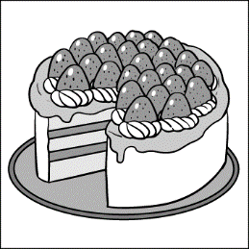 (Ｃ)
- （ ）
(Ａ) 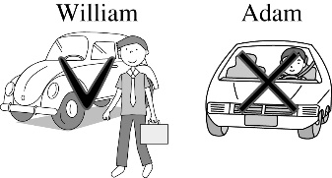 (Ｂ) 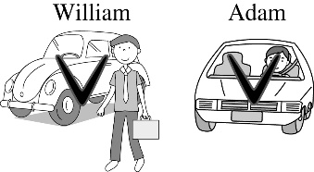 (Ｃ) 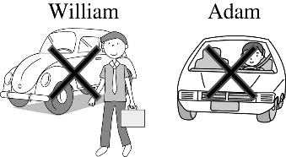
- （ ）
(Ａ) 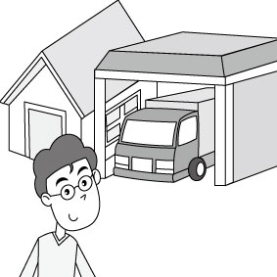 (Ｂ) 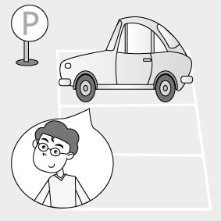 (Ｃ) 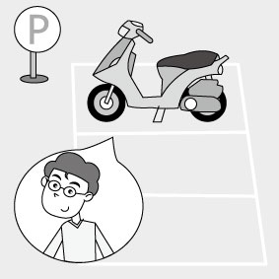
- （ ）
(Ａ) 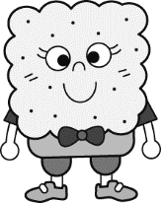 (Ｂ) (Ｃ)
5. （ ）
(Ａ) (Ｂ) 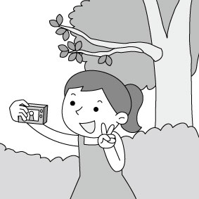 (Ｃ) 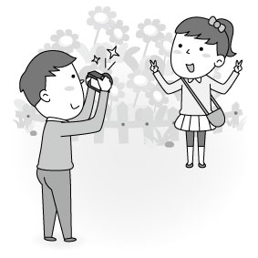
二、基本問答：根據聽到的內容，選出一個最適合的回應或最適合的問句。（每題2分，共10分）
6.（ ）(Ａ) Because I like indoor sports. (Ｂ) Because I had a terrible dream. (Ｃ) Because I have no interest in it.
7.（ ）(Ａ) Today’s Career Day was very successful. (Ｂ) Choosing a correct career is very important.
(Ｃ) Well, I’ll be a farmer after I finish my study.
8.（ ）(Ａ) Yes, the T-shirt cost an arm and a leg. (Ｂ) No, but Lucy does. They are close friends.
(Ｃ) Yes, they have the same T-shirts.
9.（ ）(Ａ) I’ll clean my room and tidy it up. (Ｂ) Let me fix the floor problem. (Ｃ) My room is on the second floor.
10.（ ）(Ａ) In 1994. (Ｂ) I grew up here. (Ｃ) I used to live in the south.
三、 字彙選擇：（每題2分，共10分）
11. ( ) Lily likes to . She spends most of her time growing flowers and plants.
(Ａ) relax (Ｂ) build (Ｃ) pray (Ｄ) garden
12. ( ) A: I failed the test again. B: It’s not the end of the world.
(Ａ) So far so good. (Ｂ) Cheer up! (Ｃ) I can’t help it. (Ｄ) Count me in!
13. ( ) Dad, can you help the difficult math problem? I can’t make heads or tails of it at all.
(Ａ) pack (Ｂ) fix (Ｃ) last (Ｄ) save
14. ( ) Stella, stop eating so much junk food, or you’ll never have a chance to get .
(Ａ) fat (Ｂ) rich (Ｃ) slim (Ｄ) thick
15. ( ) The thief（小偷）ran away he saw the police officer.
(Ａ) as soon as (Ｂ) as long as (Ｃ) as fast as (Ｄ) as possible as
四、文法選擇：（每題2分，共20分）
16. ( ) This is the story about they talked this morning. (Ａ) who (Ｂ) which (Ｃ) that (Ｄ) ×
17. ( ) She is the roommate with Amy lives. (Ａ) who (Ｂ) whom (Ｃ) × (Ｄ) that
18. ( ) This is the most interesting book I’ve ever read. (Ａ) that (Ｂ) who (Ｃ) what (Ｄ) which
19. ( ) The smartphone Sam bought last week is the latest（最新的）on the market.
(Ａ) for which (Ｂ) to that (Ｃ) which (Ｄ) who
20. ( ) My brother was sick, and so my parents. (Ａ) were (Ｂ) was (Ｃ) are (Ｄ) did
21. ( ) Kelly has to see a doctor, and you , too. (Ａ) do (Ｂ) have (Ｃ) had (Ｄ) are
22. ( ) Sony’s never been to Keelung, and his sister. (Ａ) neither is (Ｂ) so is (Ｃ) so has (Ｄ) neither has
23. ( ) Mr. Lee didn’t buy a car, and Mr. Wang didn’t, . (Ａ) too (Ｂ) either (Ｃ) so (Ｄ) neither
24. ( ) We used the new idea us a lot of time and money. (Ａ) that were saving (Ｂ) who saves (Ｃ) which saved (Ｄ) saved
25. ( ) Our class leader, Jimmy, is always the last one the classroom. He makes sure the doors and the windows are closed before going home. (Ａ) that leave (Ｂ) which leaves (Ｃ) that are left (Ｄ) who leaves
- 對話與完成句子：（每題2分，共2分）
26. ( ) A: Dick, what happened? B: I didn’t do well on the test and I lost the basketball game.
(Ａ) I was too surprised. (Ｂ) Today was really not my day. (Ｃ) I can do everything right. (Ｄ) Nothing. I’m okay.
六、克漏字測驗：（每題2分，共8分）
There was a robbery in the bank near my house. It (1) around three twenty in the afternoon. It was almost the time to be closed. Suddenly, a tall heavy man (2) a black mask ran into the bank. All the people in the bank were too scared to move because the man had two guns. He asked the tellers (3) money into his big bag, and then he left the bank right away. The guard ran after him but failed to catch him, who rode a motorcycle away fast. A young man recorded everything with his smartphone and gave it to the police. It is said that the robber (4) this early morning and that all the money was taken back.
27.（ ）(Ａ) happening (Ｂ) happened (Ｃ) happens (Ｄ) to happen
28.（ ）(Ａ) who wore (Ｂ) wore (Ｃ) was wearing (Ｄ) worn
29.（ ）(Ａ) putting (Ｂ) put (Ｃ) to put (Ｄ) puts
30.（ ）(Ａ) was caught (Ｂ) has caught (Ｃ) is caught (Ｄ) will be caught

- 閱讀測驗：（每題1分，共11分）
Four hundred students at ZhongShan Junior High School were asked what their hobby is. Please look at the bar chart and answer the questions.

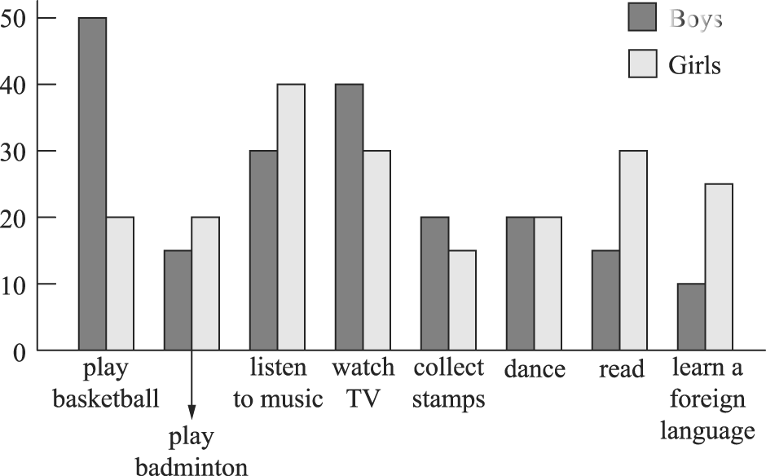

31.（ ）Which is boys’ favorite hobby? (Ａ) Playing badminton. (Ｂ) Watching TV. (Ｃ) Playing basketball. (Ｄ) Dancing.
32.（ ）Which hobby do girls like the least?
(Ａ) Listening to music. (Ｂ) Collecting stamps. (Ｃ) Reading. (Ｄ) Learning a foreign language.
33.（ ）How many students like to learn a foreign language? (Ａ) 35. (Ｂ) 30. (Ｃ) 25. (Ｄ) 10.
34.（ ）Which ISN’T true?
(Ａ) More girls like learning a foreign language than boys. (Ｂ) Only 10% of the girls like dancing, and so do boys.
(Ｃ) Students like watching TV better than playing sports. (Ｄ) Fewer boys like playing badminton than girls.

Ireland is a green country with lots of sheep. When the sun shines, it’s very beautiful. St. Patrick’s Day is celebrated on March 17. Patrick is a saint of Ireland, but he is not an Irish. He was born in Wales. When he was about 16 years old, pirates caught him and took him to Ireland. They sold Patrick to a rich man, and he took care of the man’s sheep. During this time, Patrick started to believe in God. After six years, Patrick ran away and then became a monk in France. Later he decided to go back to Ireland and tell people about God. Patrick taught there for about 30 years. He taught people about God, and he also taught them how to read.

35.（ ）Where was Saint Patrick born? (Ａ) In France. (Ｂ) In Ireland. (Ｃ) In the USA. (Ｄ) In Wales.
36.（ ）How old was Patrick when he became a monk in France? (Ａ) Over 40. (Ｂ) About 22. (Ｃ) 16. (Ｄ) Less than 16.
37.（ ）Which is NOT true about this reading? (Ａ) Patrick was an Irish person. (Ｂ) St. Patrick’s Day is on March 17.
(Ｃ) Ireland is a country with a lot of sheep. (Ｄ) Patrick taught people how to read in Ireland.

Dr. Albert Schweitzer（史懷哲）was born in Germany in 1875 and died in West Africa in 1965. He was a doctor who went to Africa to help Africans. However, Schweitzer didn’t plan to be a doctor until he read a story about the poor people in Africa. He then decided to study medicine, and seven years later, he became a doctor. At age 38, he and his wife, Helen, went to West Africa. He helped the sick people there for over 50 years. Also, because of his hard work, many people got to know how poor Africans were and donated money to help build a hospital there. For his devotion, Dr. Schweitzer is and will always be remembered for what he did to help the people in Africa.

38.（ ）What can we learn from Dr. Albert Schweitzer? (Ａ) The spirit（精神）of giving. (Ｂ) The tips for writing stories.
(Ｃ) The skill of communicating. (Ｄ) The different use of medicine.
39.（ ）Why do people respect Dr. Albert Schweitzer?
(Ａ) He donated a lot of money to Africans. (Ｂ) He wrote stories about the poor in Africa.
(Ｃ) He taught people in Africa how to build a hospital. (Ｄ) He helped the sick people in Africa for over 50 years.
Look at the clinic hours of a hospital and answer the questions.
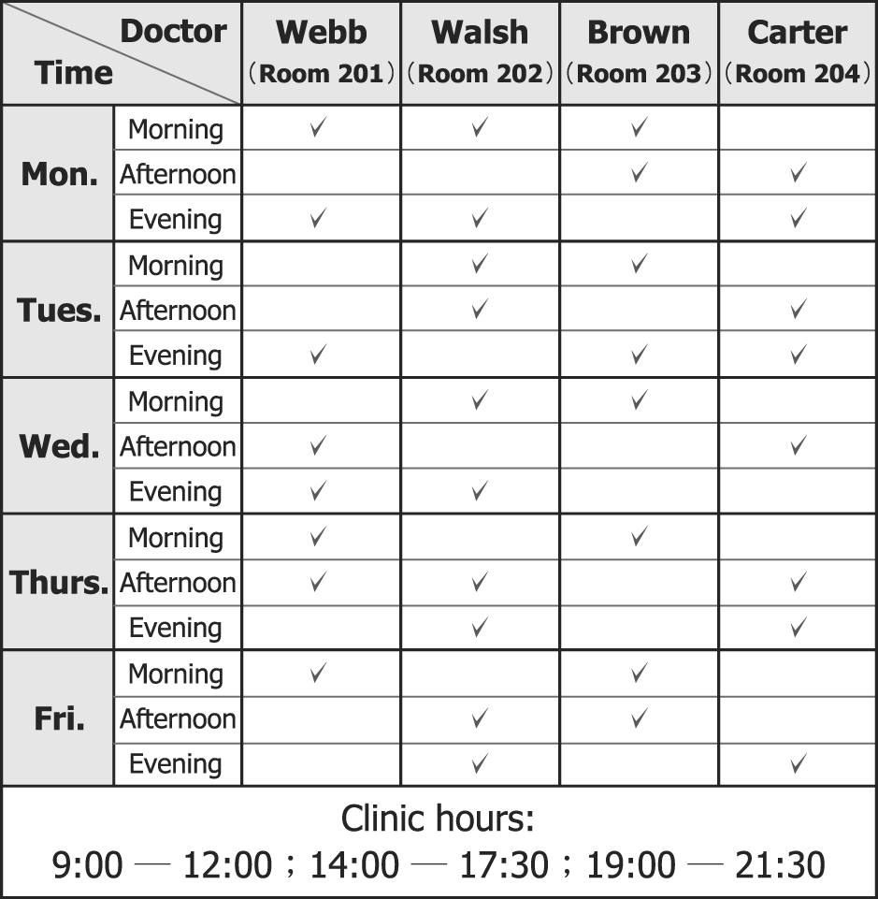
［102.基測］

40.（ ） Cary made an appointment（預約） to see Dr. Brown on the afternoon of June 15. But the hospital told him that Dr. Brown could not see him that day because of an important meeting. Cary was told that he could still come to the hospital at that time, but he would have to see Dr. Walsh in Room 202. On what day is June 15?
(Ａ) Monday. (Ｂ) Tuesday. (Ｃ) Thursday. (Ｄ) Friday.
41.（ ） Gillian came to see her eye doctor in the morning. After checking her eyes, her doctor told her to come back next Monday evening. But Gillian has to work evenings, so her doctor told her to come back next Wednesday afternoon. Which doctor did Gillian see? (Ａ) Dr. Webb. (Ｂ) Dr. Walsh. (Ｃ) Dr. Brown. (Ｄ) Dr. Carter.
- 填充題：（每題2分，共10分）
42至43題請填入正確的附和句
42. My dad’s never been to China, and __________ __________ I.
43. My brother put it on before going out, and __________ __________ my sister.
44題請填入正確的介系詞
44. People __________ eighteen years old can’t ride a motorcycle.
45題請填入適當的關係代名詞
45. The cat __________ has white hair is mine.
46題請填入適當的動詞形式
46. I, who __________(be) your best friend, will always help you.
- 依提示作答：（每題3分，共9分）
- We won’t go on a trip, and they won’t, either. (請用…neither…改寫句子)

__________________________________________________________________

- The man is a great cook. The man has a big nose. (用介系詞片語合併成一句)

_________________________________________________________________

- She was the only girl.
I danced with the girl at the party. (用關係代名詞，將第二句併入第一句)

__________________________________________________________________________________
- 佳句翻譯填空：（每題2分，共10分）
- __________ is its own __________, isn’t it?
為善自得其樂，對吧？
- To __________ your needs, I will do my __________.
為了滿足你的需求，我會全力以赴。
- __________ the bridge when you come to it.
船到橋頭自然直。

