基隆市立中山高中109學年度第一學期第三次月考高一英文科試題卷
範圍: 龍騰版第一冊第七至九課全 請劃卡
Live Dec. / 核單U6—10
- Voc. 10%(核單)
- There is no _____ that Kevin is the best player on our basketball team.
- mixing (B) daring (C) denying (D) ranging
- I ______ to eat less in summer because the high temperatures ruin my appetite.
- aim (B) tend (C) wonder (D) sweep
- Ginger and garlic are frequently used to _______ dishes in Asian countries.
- season (B) consume (C) boast (D) pride
- I prefer to buy shoes made of ______ leather because they are more comfortable.
- selective (B) regional (C) capital (D) genuine
- You should dress _______ for job interviews. Jean and T-shirts are not acceptable.
- originally (B)additionally (C) properly (D) particularly
- This rose is easy to look after since it has great _______ to disease.
- product (B) bacteria (C) resistance (D) content
- Not everyone agrees that making more money ______ more happiness.
- desires (B) performs (C) tricks (D) equals
- To be a top lawyer, you must take the ________ very seriously and work long hours.
- profession (B) attention (C) selection (D) addition
- ______ plays an important role in people’s lives, from diets to festivals.
- Achievement (B) Convenience (C) Religion (D) Romance
- I wouldn’t forgive Mike _____ he apologized to me for his bad manners.
- since (B) because (C) while (D) unless

- Cloze 24%
Every Christmas Eve, I place a white envelope in our Christmas tree. This started because my husband, Mike, disliked that Christmas had become commercial __11__ all the shopping and gift-giving. He thought that these superficial rituals __12__ the true meaning of Christmas.
A few weeks before Christmas, while we were watching my son’s wrestling match, I suddenly realized __13__ the gift should be. Kevin’s team was competing __14__ a team of poor kids. They looked ragged in their old uniforms. Mike said, “losing today could __15__ those kids quit.” Mike knew kids well because he coached them in sports __16__ his free time. Later, I bought some sports equipment for them. I shared my good deed __17__ Mike in a note and put it in a white envelope. On Christmas Eve, I put it in the tree as a gift from me. When he opened it the next morning, he said it was perfect. That’s when we decided to do this every year at Christmas time. Every year, Mike and our kids __18__ opening the white envelope.
- (A) by (B) into (C) with (D) to
- (A) overshadowed (B) overlooked (C) overflowed (D) overthought
- (A) that (B) which (C) what (D) why
- (A) against (B) for (C) across (D) opposite
15.(A) cause (B) lead (C) make (D) allow
16.(A) by (B) of (C) on (D) in
17.(A) for (B) with (C) of (D) about
18.(A) had no choice but (B) couldn’t help (C) looked forward to (D) couldn’t wait to

1
Convenience stores use smart marketing strategies to make you spend more in their stores. One of them is to follow the “eye level is buy level” rule. The more easily you can see the products, the more __19__ you are to buy them. Therefore, the most __20__ items are put at the average shopper’s eye level. __21__, products like toys aimed at children are placed on lower shelves, so that children can easily see them. Another strategy is to promote impulse buying of small, cheap goods, such as candy bars. While you are waiting to __22__, you may grab some of them near cash registers. The method is to offer customers cheap and simple pleasures that are within easy __23__. The third strategy is to make you __24__ to stay longer in the stores by __25__ bar-style eating or dining areas. Though you just buy a drink in the beginning, you may buy more things in the end as you grow hungry. To avoid __26__ for shop owners’ tricks, watch out for these ways they use to get deeper into your pocket.
19. (A) possible (B) similar (C) likely (D) visible
20. (A) profitable (B) immediate (C) alert (D) regional
21. (A) Thus (B) To be frank (C) Otherwise (D) Similarly
22. (A) look up (B) take out (C) pick up (D) check out
23. (A) trap (B) aspect (C) reach (D) advantage
24. (A) able (B) willing (C) occupied (D) aware
25. (A) lining up (B) getting off (C) starting off (D) setting up
26. (A) falling (B) to fall (C) of falling (D) fall

It’s not often that a little-known animal becomes a social media star, but that’s exactly what __27__ a smiling Australian creature called a quokka. Quokkas are cat-sized marsupials that mainly live on small islands in the island of Rottnest near Perth, Australia. Its name comes from a __28__ native Australian word. Quokkas have round, compact bodies that are 40-54 cm _29__ length. They are covered with short, coarse brown-grey fur and have small rounded ears and a black nose. Its appearance has led some to describe quokkas __30__ the world’s happiest animals. While they appear to smile for camera, they are, __31__, not especially social. They don’t __32__ groups, play together, or groom each other. On the other hand, quokkas are eager to start their own families. They give birth just 27 days after mating. The tiny, pink, hairless and blind joey then finds its way to its mother’s pouch __33__ it stays for around six months. If the joey doesn’t survive, the mother can give birth to another one shortly after because she has others in her womb in a suspended state of development as back-up in case tragedy befalls the older joey. Unfortunately, the cute creatures’ survival is __34__ mainly because of bushfires and habitat loss.
27. (A) happened to (B) catered to (C) shrank to (D) caused harm to
28. (A) similarly-sounding (B) similar-sounding (C) similarly-sounded (D) similar-sounded
29. (A) at (B) in (C) on (D) with
30. (A) like (B) for (C) as (D) of
31. (A) in fact (B) after all (C) even worse (D) all in all
32. (A) cast (B) chop (C) threaten (D) form
33. (A) which (B) where (C) when (D) why
34. (A) at risk (B) in the air (C) at stake (D) in danger (選錯的)
- 文意選填 (請忽略大小寫) 16 %
(AB) bind (AC) temperature (AD) what (AE) with (BC) that ( BD) for (BE) while
Cheap, reliable, and strong, the rubber band is one of the world's most ubiquitous products. It holds papers together, prevents long hair from falling in a face, acts as a reminder around a wrist, and is a playful weapon in a pinch. __35__rubber itself has been around for centuries, rubber bands were only officially patented less than two centuries ago. Several thousand years ago, the native people of South America discovered rubber. They mixed tree sap __36__ juice from plants and it created a solid substance. Rubber arrived in Europe in 1736 and quickly became popular. In the 1800s, Englishman Thomas Hancock invented rubber bands. Unfortunately, they would go soft or hard based on the __37__, so they weren’t very useful. It wasn’t until vulcanization was developed __38__ made reliable rubber bands possible. They were used mostly in factories for many years. However, in 1923 an American businessman named William Spencer sold rubber bands to newspapers to __39__ their newspapers so they wouldn’t blow apart on people’s lawns. Soon, they became a common household item.
2
(AB) being (AC) for (AD) like (AE) descriptions (BC) showing (BD) besides (BE) thus
Rouen, situated on the banks of the River Seine, is Normandy’s vibrant, historic and cultural capital. Monet’s famous _40_ of Rouen Cathedral have made this vast edifice many visitors’ favorite building in the city, but there are also many fine museums to explore, not to mention the Gros Horloge clock tower, which has two clock faces, each __41__ a golden sun casting 24 rays against a blue night sky. __42__, fans of history can visit the Church of Saint Joan of Arc, where in 1431, English soldiers burned St. Joan at the stake during the Hundred Years’ War. This boat-shaped church is known __43__ its sixteenth-century stained glass windows. Rouen’s historic center is also packed with tempting shops and restaurants, and great weekly markets. This __44__ a university town, there is an energetic nightlife too.

(AB) nothing but (AC) however (AD) contrast (AE) what’s worse (BC) whereas (BD) stands for (BE) comes in (CD) to begin with (CE) sets up
Graffiti, which means “scratched” in Italian, often shows up on walls or public property in cities. This form of art __45__ different sizes and shapes. Many graffiti artists draw with a certain purpose in mind. Take Banksy for example. This famous artist delivers his opinions and has influenced the world with his paintings. Many of his works __46__ the horror of war with the innocence of children. His works call attention to the need for positive change in the world. __47__, people have different views toward graffiti. Some regard it as vandalism, __48__ others look upon it as a true art. For those who are against graffiti, it is __49_ visual pollution. _50__, graffiti is often believed to be associated with crimes.
- Reading Comprehension 4%
Ken and Marie are working on a project for a business course. For this project, they must research food delivery apps and create a competitive app of their own. In the conversation below, they are discussing their research results.
Marie: Let’s talk about Chart 1 first; how long do you expect it should take for people’s food to be sent to them? The results show that almost 70% of people hoped that their food would be delivered within 20 or 30 minutes. By contrast, only a few people said they hoped their food would be delivered within 10 minutes. These results are not in line with my initial expectations; I thought that most people would hope to enjoy their food as soon as possible.
Ken: Interesting. Maybe we should conduct follow-up interviews to find out these people’s reasons for their responses so that we can develop more effective marketing strategies. Also, I noticed that only about 5% of people said that they were willing to wait 50 minutes or more for their orders.
Marie: Exactly. So we should make sure that our app doesn’t allow orders to be made from beyond a certain distance from the restaurant to be placed.
Ken: Hey, take a look at Charts 2 and 3. We’ve checked Mealy and FoodyQ, the two leading existing apps. Most of the restaurants on those apps offer drinks and Taiwanese dishes in our neighborhood. Besides those, it is shown that these two kinds of food are also high on the customer’s demand list, although they are not commonly found on the existing platforms.
Marie: That’s good information and could be a good start to making our app the best choice.
51.Which of the following is NOT a conclusion of the above discussion?
(A) Ken and Marie intend to find out why people do not expect their food to be delivered within a short period of time.
(B) Ken and Marie intend to count and categorize the restaurants on Mealy and FoodyQ.
(C) Ken and Marie intend to make sure that the app they design will not allow long-distance orders to be placed.
(D) Ken and Marie intend to explore restaurants that are not listed on Mealy and FoodyQ.
52. Which of the following is likely to be Chart 1?
(A) (B)
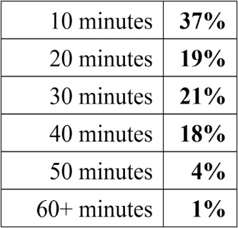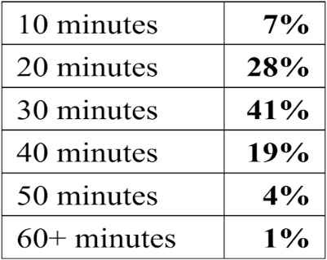
3
(C) 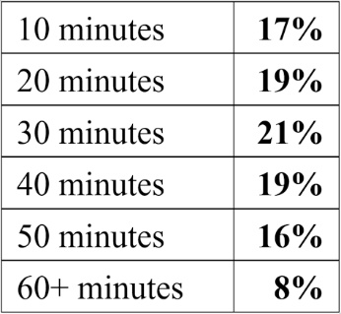 (D) 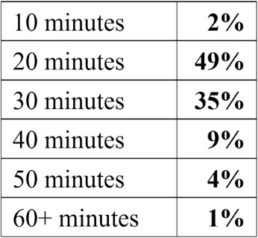

53. Please read Charts 2 and 3 carefully. What does “these two kinds of food” refer to?
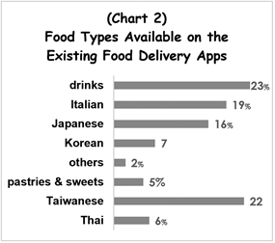
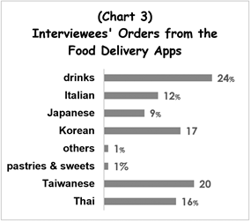

Answer: ____________ and ____________ foods. (這題答案寫在答題卷)

4
基隆市立中山高中109學年度第一學期第三次月考高一英文科答題卷
Class: Name: No: Score:
- Voc. 12%
- There are more cases of domestic vi_______ce in our society in recently years.
- After several days of heavy rainfall, a flood d_______yed the village and left hundreds of people homeless.
- When the seat belt signs are on, passengers on the airplane are not p_____ted to get up.
- John got lost because he was not fa________ar with the neighborhood.
- You are complaining about my bugging you, but you will e______y realize that I really care about you.
- The ad_______ge of shopping online is that it saves you both money and time.
- A number of p_______l buyers have expressed interest in the product and are waiting for a drop in the price before buying it.
- I can b________y understand what you are saying. Could you please explain it in plain language?
- The major s_______r, whose logo can be seen on the sports team’s polo shirts, have given the team a lot of financial support.
- Smart and hardworking, Chinese students are very (compete) in foreign countries.
- The volunteers hold activities to raise public (aware) of the importance of ecological conservation.
- The destructive power of fake news (horror) people so we have to think carefully and judge wisely when we read news.
- Translation 12% (錯一個字扣0.5分)
- 父親在十八歲時養成抽菸的習慣，從那時候起他就發覺很難戒掉。(2%)
Dad developed the habit of smoking when he was 18, and has found it hard to quit ever since.
- 根據研究，害羞的人可能會有較少的朋友。(2%)
According to studies, shy people are likely to have fewer friends.
- Peter擅長修理電腦。說到這，沒有人比得上他。(4%)
Peter is good at repairing computers. When it comes to this, he is second to none.

- 雨下得越久， 我們越知道如何在室內開心地過日子。 (4%)
The longer it rains, the more we know how to spend our days indoors pleasantly.

III. Reading Comprehension 2%
53. Please read Charts 2 and 3 carefully. What does “these two kinds of food” refer to?

Answer: Thai and Korean foods.
.

- Voc. 12%
1  violence | 2  destroyed | 3  permitted | 4  familiar
5  eventually | 6  advantage | 7  potential | 8  barely
9  sponsor | 10  competitive | 11  awareness | 12  horrifies

5

