基隆市立中山高中110學年度第一學期第二次段考英文聽力試題卷
考試班級：高三忠孝仁 請用新電腦卡 姓名: ________________
Part A
Please listen to the conversation or short talk and choose the most suitable picture for what you hear.

Question 1 ( )
(A) | (B) | (C)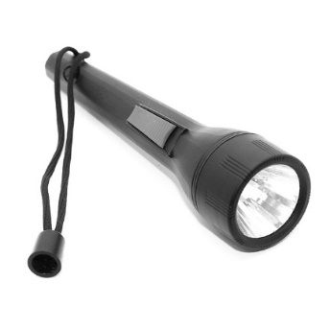 | (D)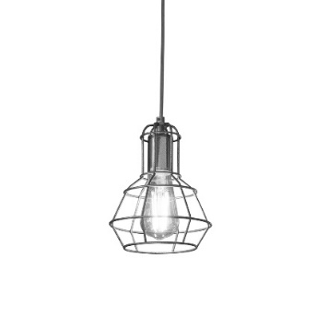
Question 2 ( )
(A) | (B) | (C) | (D)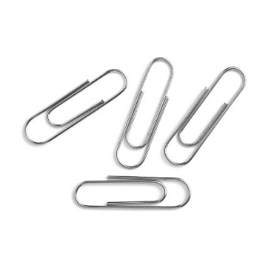
Question 3 ( )
(A) | (B) | (C)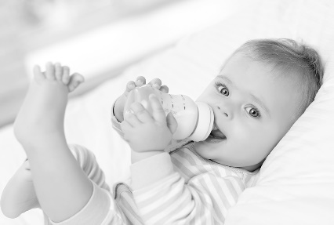 | (D) 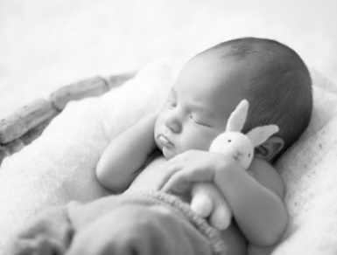
Question 4 ( )
- 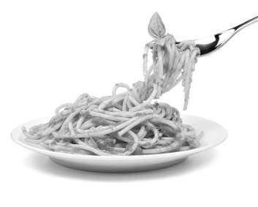 | - 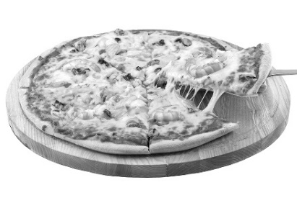 | - 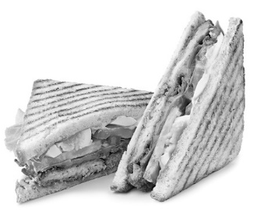 | - 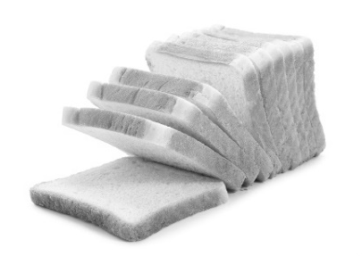
Part B
Please listen to the question and choose the two best answers according to what you see in the picture.
Question 5 ( ) ( ) | Question 6 ( ) ( )
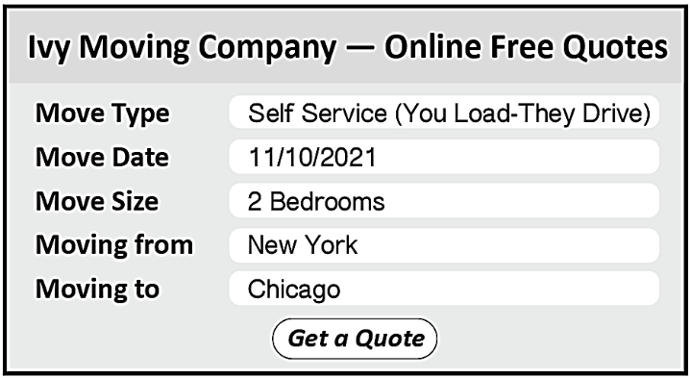 | 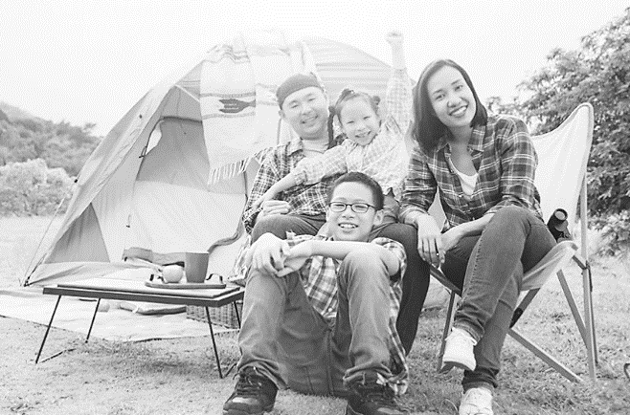
Question 7 ( ) ( ) | Question 8 ( ) ( )
 | 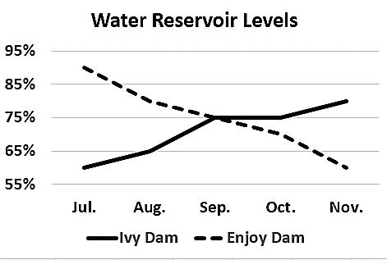

Part C
After you hear each question or statement, read the four possible answers and decide which one is the best response.
9. (A) He bought the expensive car after he had won the lottery.
(B) Turn left on Apple Road. You’ll see the café on your left.
(C) You need to take this paper to the bank in order to collect your salary.
(D) That seems fair. People need to know that actions have consequences.
10. (A) Yes, we leave for our tropical honeymoon tonight!
(B) We got married in San Francisco, not in New York.
(C) I guess I am just a bit anxious about our future together.
(D) No, I didn’t get invited to her wedding last Sunday.
11. (A) He must have been very thirsty, then. (B) That’s horrible! Was he okay after, though?
(C) The child purposely made himself ill. (D) Everyone should drink 2,000 cc of water per day.
12. (A) I did. Those poor kids looked so dirty and hungry. (B) It was such an awesome story. I feel inspired.
(C) The daily newspaper only costs fifty cents. (D) I’m sorry. It won’t happen again. I promise.
13. (A) Yes, I think it is very easy to understand.
(B) No, there isn’t really anything special about it.
(C) I’m a good web designer and have five years of experience.
(D) We have a clear beach view from this room.
14. (A) Doesn’t this new dress look amazing on me? (B) I totally agree with you. I don’t like it either.
(C) We have to clock in before eight o’clock. (D) I couldn’t wash out the stains on this skirt.
15. (A) Yes, I have a dentist appointment today. (B) No, I’m not sure where that odor is coming from.
(C) I totally agree. The fridge in the kitchen stinks. (D) Oh, no! I’ll brush my teeth right away.
16. (A) No, this project is way too big for her to deal with by herself.
(B) Yes, she has ambitions to become a movie director.
(C) She turned the handle, but the door was locked.
(D) We’ll discuss who should be in charge of the task next Friday.

Part D
After you hear each conversation and question, read the four possible answers and decide which one is the best answer.
17. (A) Something terrible has happened. (B) The woman has a religious belief.
(C) Some important news was broadcast on TV. (D) The woman showed no sympathy for the man.
18. (A) Making hot dogs. (B) Competitive eating. (C) Dinner plans. (D) A training exercise.
19. (A) She’s happy because she likes hot peppers.
(B) She doesn’t want to hire people who hate spicy food.
(C) He doesn’t know if she is going to run her own farm.
(D) He is surprised that she is excited to work at the farm.
20. (A) People who have been killed by the police. (B) Why people make so many mistakes.
(C) What might happen because of a fake gun. (D) The threats real guns pose.

第21、22題為題組
21. (A) Plans to honor a living celebrity. (B) An upcoming action movie.
(C) A famous COVID-19 expert. (D) The death of a beloved actor.
22. (A) She doesn’t believe it’s true. (B) She is very saddened by it.
(C) She feels angry and frustrated. (D) She’s happy that he’s in a better place.

第23、24題為題組
23. (A) He always buys six packages of the expensive brand.
(B) He will buy the cheaper brand next time.
(C) He thinks the expensive brand is better. (D) He prefers buying cheaper brands.
24. (A) Disapproving. (B) Enthusiastic. (C) Sympathetic. (D) Accepting.
Part E
Please read the questions and choose the best answer for each question after you hear the short passage.
I. 25. Which is mentioned as one of the deepfake uses?
(A) Making a prank call. (B) Identifying human faces.
(C) Using the internet to play a trick. (D) Improving a person’s appearance.
26. According to the passage, what is unique about the K-pop group Eternity?
(A) It is at the top of the music charts. (B) It was created to fool people.
(C) It is a company’s first project. (D) It was completely generated by computer.
II. 27. What experience is SSS related to?
(A) Traveling experience. (B) Cooking experience.
(C) Dieting experience. (D) Dining experience.
28. Why does SSS usually occur with desserts?
(A) They greatly improve digestion. (B) They present a different flavor.
(C) They are simply too tempting. (D) They are easily obtained.
III. 29. What does the “lipstick effect” phenomenon refer to?
(A) Being passionate about makeup products. (B) Favoring expensive brands over cheap ones.
(C) Using lipsticks to make oneself feel confident. (D) Buying small luxury goods when one has little cash.
30. Why did Leonard Lauder of Estée Lauder choose the “lipstick effect” name?
(A) He witnessed a trend in lipstick sales. (B) He sold more lipstick than any other cosmetics.
(C) He tried to get free advertising for his company. (D) He wanted to get employed in the luxury goods market.
IV. 31. According to the passage, which statement about UPFs is correct?
(A) They’re more popular among elementary school kids.
(B) They have made the overweight population increase.
(C) People in the UK eat the most UPFs.
(D) It’s not difficult to stay away from them.
32. What is NOT true about Dr. van Tulleken’s experiment?
(A) His health was tracked throughout the experiment.
(B) Experiment results were shown in a documentary.
(C) He had only one MRI at the start of the experiment.
(D) The experiment was conducted by the UCL.

Part F
Please look at the chart and read the options. Use the chart to write down important information and details as you listen to the conversation or talk. Choose the best answer for each question you hear. (What you fill in on the chart won’t count towards your score.)
I.
Earliest Canals
constructed in around 4000 BCE examples: The Foss Dyke Canal by the Romans
their uses: 1. growing crops 2. supplying
3. providing convenient navigational routes
Three Well-known Canals in the World
Canal | The Grand Canal | The Suez Canal | The Kiel Canal
Length | km | km | km
Built /
Opened
Functions | transporting _______________

33. (A) Leisure activities. (B) Goods transportation.
(C) Providing water that is safe to drink. (D) Offering water for personal washing.
34. (A) The Grand Canal. (B) The Foss Dyke Canal
(C) The Kiel Canal. (D) The Suez Canal.
35. (A) To aid in trade between countries. (B) To transport plants.
(C) To strengthen their military force. (D) To grow crops.
36. (A) The Suez Canal > The Kiel Canal > The Grand Canal
(B) The Grand Canal > The Kiel Canal > The Suez Canal
(C) The Suez Canal > The Grand Canal > The Kiel Canal
(D) The Grand Canal > The Suez Canal > The Kiel Canal

II.
Flamingos
1. physical features:
height: grow to be
weight:
feather colors:
from

2. life span:
3. social birds:
# enjoy living in large groups
# a group of flamingos is called
4. one-legged stance:
#
# to prevent heat loss when they stand in the water

37. (A) They can weigh up to 3.6 kg.
(B) They can grow to 1.5 meters
(C) They sometimes have orange feathers.
(D) They can live for 14 to 16 years.

38. | (A) | (B) | (C) | (D)
 |  |  | 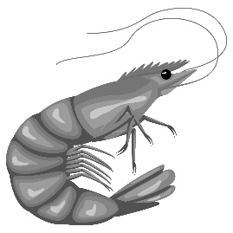

39. (A) School. (B) Colony. (C) Swarm. (D) Army.

40. (A) To protect their joints.
(B) To conserve energy.
(C) To stay alert to danger.
(D) To communicate with one another.

