基隆市立中山高中110學年度第二學期第二次段考一年級英文聽力
班級 座號 姓名

一、Picture Description
For each of the following questions, you will hear one statement and you will see four pictures. Only one of the pictures is described by the statement. Choose the ONE PICTURE that is described by the statement.
- 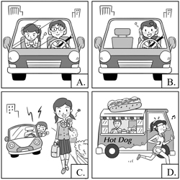
- 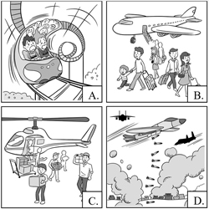

- 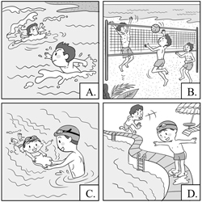

- 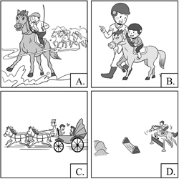
- 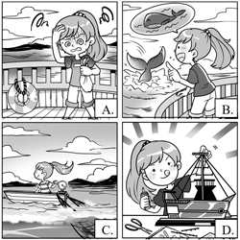
- 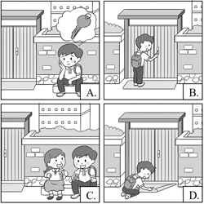
- 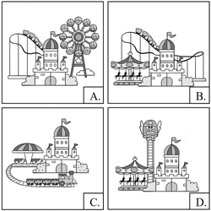
- 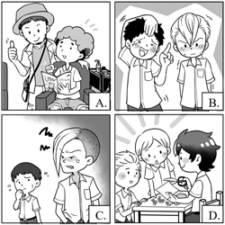
- 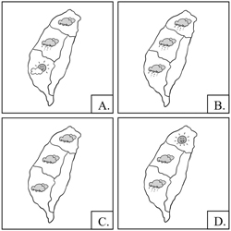
二、Single Sentence Comprehension
Listen to the following questions or statements, and then read the four possible responses. Choose the most appropriate response to each question.
- (A) Did you need to take some medicine?
(B) Did you two eat something spicy?
(C) Did you express your anger to his face?
(D) Did you go to see a doctor?

- (A) All his efforts were in vain.
(B) His hard work finally paid off.
(C) No one wanted to assist him.
(D) It’s a breakthrough in science.

- (A) She prefers the passenger seat.
(B) She enjoys driving a race car.
(C) She is afraid of driving fast.
(D) She can’t afford a new car.

- (A) It’s fortunate no one died of SARS.
(B) The doctor established the monument.
(C) The doctor is worthy of our respect.
(D) No one agreed with the doctor.

- (A) I’m glad that we’ve reached a conclusion so fast.
(B) The discussion is led by the head of our department.
(C) Let’s call it a day and we’ll meet at the same time tomorrow.
(D) I really need a break before we continue the discussion.

- (A) Maybe it’s his birthday card.
(B) Maybe it’s his report card.
(C) Maybe it’s a shopping list.
(D) Maybe it’s a clue.

- (A) You can check with him again.
(B) He never breaks his promises.
(C) I think he’s a total liar.
(D) He sticks to his principles.

- (A) The grades will be revealed next week.
(B) I have the same feeling when exam time comes.
(C) She is well-prepared and expects to win.
(D) Anxiety affects her performance on tests.

- (A) The company will lower the product price soon.
(B) It is normal that companies want to make more money.
(C) Different materials will cause differences in functions.
(D) This company is famous for high quality products.

- (A) The fast pace of life in a city never bothers me.
(B) I wouldn’t even consider buying a house in the countryside.
(C) The band’s limited album is really expensive.
(D) That’s really a big problem of living in cities.

- (A) That’s confusing. He can’t find any evidence.
(B) That’s terrible. No one wants to fix the problem.
(C) That’s interesting. The evidence is against him.
(D) That’s scary. He should be careful of his safety.

- (A) I’ll ask my mom to write her name.
(B) You don’t have to worry about your absence.
(C) Hearing that, my father let out a sigh of relief.
(D) It’s a warning sign that we can’t ignore.

- (A) The elderly tend to have knee problems.
(B) It must have bothered her for a long time.
(C) She may need to take yoga class occasionally.
(D) She is a persevering and determined woman.

- (A) I’m getting tired of climbing up.
(B) When the winds blow, I can’t help trembling.
(C) Suddenly I have to put on a thick jacket.
(D) It’s getting colder little by little along the way.

- (A) It provides a wide variety of alcoholic beverages.
(B) Flight attendants will bring them food and snacks.
(C) Passengers can watch movies or play video games.
(D) Passengers will get an eyeshade and earplugs.

三、Dialogue Comprehension
Listen to the following short conversations, and then listen to the question that follows each conversation. Choose the best answer to each question.
- (A) She will have a slender figure.
(B) She will gain protection against infection.
(C) She will be able to move more easily.
(D) She will finish her diet plans effectively.

- (A) She became the champion.
(B) She survived the disaster.
(C) She finished the training.
(D) She fulfilled her dream.

- (A) It’s under restoration.
(B) It’s a private place.
(C) It’s not open yet.
(D) It’s only for women.

- (A) To work in a theater.(B) To watch more dramas.
(C) To collect movies.
(D) To have a front seat.

- (A) He cares too much about test scores.
(B) He doesn’t work hard enough at school.
(C) He may have some mental disease.
(D) He tends to believe whatever people tell him.

- (A) The store sells the tie.
(B) The tie is no longer sold.
(C) She can get a discount.
(D) She can get the tie in time.

- (A) They will be interviewed one after another.
(B) They will be told the results by the woman.
(C) They will listen to the woman’s explanation.
(D) They will be gathered in the same room.

- (A) He hasn’t been accepted by the new classmates.
(B) He doesn’t dare to talk to his new classmates.
(C) He can’t understand what the teacher said.
(D) He tends to feel depressed easily.

- (A) The boss told him.
(B) The head of the department told him.
(C) He joined in on the discussion.
(D) He heard it accidentally.

- (A) That can teach William something.
(B) That can keep William quiet.
(C) That can help him finish his homework.
(D) That can make him eat more.

四、Statement Comprehension (6小題，每題分，共0分)
Listen to the following short talks and read the questions below. Choose the best answer to each question.
- Which of the following is true about the fear of ghosts?
(A) People avoid mentioning ghost stories.
(B) The fear comes from the fear of gods.
(C) There’s a word created to describe the fear.
(D) This fear exists in only a few countries.

- Which of the following is NOT what you should do when you make a mistake?
(A) Say sorry sincerely.
(B) Promise it won’t happen again.
(C) Ask for instant forgiveness.
(D) Show that you know the problem you’ve caused.

- What can you see in the Harry Potter Studio in London?
(A) How the movies were made.
(B) How J.K. Rowling came up with the idea.
(C) How Harry Potter used his magic power.
(D) How the actors and actresses were chosen.

- Why can’t visitors bring sharp items into the museum?
(A) They take up too much space.
(B) They will influence security checks.
(C) They will affect the exhibition.
(D) They may be used to attack people.

- What is a characteristic of the TRX system?
(A) It is used in the military.
(B) Users need to use one’s core to keep balance.
(C) It helps users to lose weight.
(D) It helps build muscles in a gentle way.

- Which of the following is NOT true about the Disneyland theme park?
(A) It’s a theme park for children and adults.
(B) The theme park is based on animations.
(C) There’s a public parade every day.
(D) Not every Disney park makes a profit.

