第一部分：聽力測驗（三選一）
一、辨識句意：每題均有三張圖片，請依據所聽到的句子，選出符合描述的圖片(每個答案 2.5 分，共 10 分)
- (A)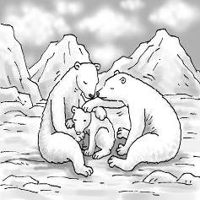 (B)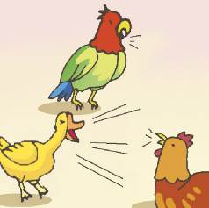(C)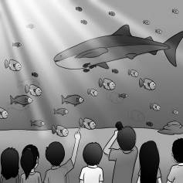
- (A)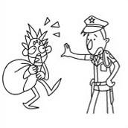 (B)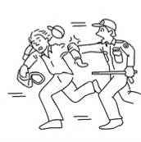(C)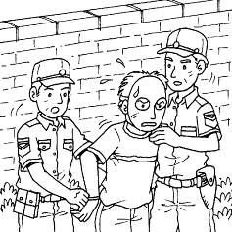
- (A)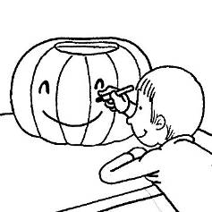 (B)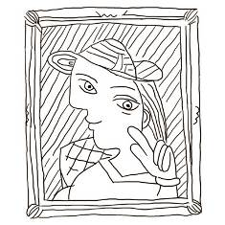(C)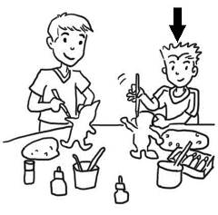
- (A)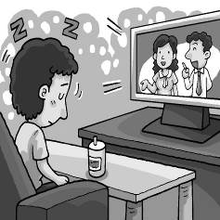 (B)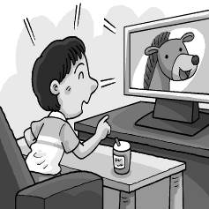 (C)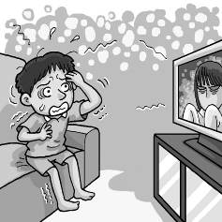
二、基本問答：每題均有三個選項，請依據所聽到的內容，選出一個最適合的回應(每個答案 3 分，共 9 分)
- (A) Let’s write something in her yearbook.
(B) I think she is a true friend to you.
(C) You need to buy a dictionary.
- (A) He doesn’t care about how he looks at all.
(B) That’s right. He looks slimmer now.
(C) Because he wants to put on weight.
- (A) Sure, but you need to paste a stamp first.
(B) Is it something you don’t need?
(C) But you already have ten.
三、言談理解：每題均有三個選項，請依據所聽到的對話與問題，選出一個最適當的答案(每個答案 3 分，共 9 分)
- (A) He had a difficult time at first.
(B) He hated to make new friends.
(C) He had fights with his classmates.
- (A) Sam doesn’t want to help Ms. Lee.
(B) Sam wants Ms. Lee to write some words in his yearbook.
(C) Sam is a student in the ninth grade.
- (A) She is going to move away with her family.
(B) She is going to clean her house.
(C) She is going to go camping with her family.

第二部分：閱讀測驗（四選一）
一、字彙測驗：(每個答案 2 分，共 14 分)
- Lucas didn’t understand what “knock out” meant in the reading below:
Everyone was knocked out by what they heard. “The song sounds so good and very different from anything I’ve heard before,” Tony said.
He looked it up in the dictionary and found more than one meaning. What does “knock out” mean here?
(A) To surprise somebody very much.
(B) To hit someone so that they cannot get up.
(C) To break something so that it does not work.
(D) To work very hard in order to do something well.

- A：My guitar ＿＿＿ starts at six p.m.
B：Wow, I didn’t know you are learning to play the guitar.
(A) farm (B) sail (C) prize (D) lesson

- The little girl ＿＿＿ her hair all the time, so her hair always looks beautiful.
(A) wishes (B) combs (C) jumps (D) paints

- A：Can your pet catch a ball or jump ＿＿＿? B：No, but he can shake hands.
(A) bell (B) paint (C) pin (D) rope

- Alice gives her best ＿＿＿ to all her friends by writing them Christmas cards every year.
(A) blanks (B) wishes (C) markers (D) pipes

- George is often late for work. He has to learn to ＿＿＿ his time well.
(A) manage (B) comb (C) wish (D) paint

- After the show, one man began to cheer and ＿＿＿, and others joined in. The students did very well.
(A) clap (B) kick (C) pray (D) wake

二、文法測驗：(每個答案 2 分，共 26 分)
- Mr. Mills bought some new books ＿＿＿ to teach his students.
(A) looked interesting
(B) that looked interesting
(C) were interested
(D) that were interested

- Emily is not sure ＿＿＿ that’s her umbrella or not.
(A) that (B) whether (C) what (D) why

- Emma told her sister ______ with knives after seeing her ______ with them. It was dangerous.
(A) not play; plays
(B) to not play; will play
(C) not to play; playing
(D) to play not; to play

- Julia tries to change how women ______ around the world and ______ up for those in need.
(A) to treat; to stand
(B) are treated; stood
(C) are treated; to stand
(D) are treating; standing

- A：I need ______ to the supermarket. Do you want me ______ anything for you?
B：No, thanks.
(A) to go; to get
(B) to go; getting
(C) going; to get
(D) going; getting

- Oliver put some beef and tomatoes in his soup to make it ＿＿＿ better.
(A) taste (B) tasted (C) tasting (D) to taste

- On my way home, I saw two women ______ a fight on the street.
(A) are having (B) having (C) to have (D) has

- The tools will ______ to you today. After you collect the water sample, ______ it back to me for testing.
(A) send; be sent
(B) be sent; send
(C) send; being sent
(D) be sending; sending

- Catherin felt ______ when she saw a rat ______ in front of her.
(A) being scared; ran
(B) scared; running
(C) to be scared; to run
(D) scared; to run

- My pet cat always likes ＿＿＿ with this big towel after I wash her.
(A) to dry (B) drying
(C) to be drying (D) being dried

- Those teachers believe it is important to teach students what ______ and ______ out from the history books.
(A) forgets; leaves
(B) will forget; leave
(C) has been forgotten; left
(D) to be forgotten; left

- A：What happened to Mary? I heard her ______ in her room, and she sounded ______.
B：She is watching a basketball game.
(A) to shout; excited
(B) shouting; excited
(C) to shouting; to be excited
(D) shout; being excited

- This Saturday is Emily’s birthday. She thinks ＿＿＿ her dad may take her to Hualien this weekend. However, she is not sure ＿＿＿ he has free time.
(A) which; when
(B) when; that
(C) that; whether
(D) what; if

三、克漏字選擇：(每個答案 2 分，共 10 分)

Do you feel that you are overweight? Do you want to lose your beer belly? Or are you thinking of going on a diet? If you are nodding your head, then you must know Michel Montignac because this guy knew a lot about diets. He wrote a book __1.__. It is called The French Diet, and in it, he said people didn’t need to diet to lose weight. He believed __2.__ than how much food they put into their bodies. He put all the foods __3.__, good ones and bad ones. The good foods were the ones that put sugar into the blood more slowly than the bad foods, and they included spaghetti, cereals, and vegetables. What’s more, they stopped the body from storing fat. That’s __4.__ it’s best to stay away from foods like candy, potatoes, and white flour. With Montignac’s way, people didn’t have to exercise very much. His way sounded easy, which was great news to food lovers. However, not everyone agreed with Montignac and his ideas.
__5.__ you believe him or not, here are some healthy ways for dieting. You should stop eating when you are 80% full. Also, you should get lots of fresh food and treat vegetables as the main meal and meat as a side dish. More importantly, enjoy your meal by eating slowly and using it as a time to spend with your family and friends.
beer belly 啤酒肚 diet 節食 nod 點頭 blood 血液 include 包含 spaghetti 義大利麵 cereal玉米片 store 儲存
（ ）31. (A) where it sits in the library
(B) which will have a lot of pages
(C) whether he read it or not
(D) that had a lot of people’s experiences
（ ）32. (A) how much time they spent in the gym really mattered
(B) the type of food they ate was more important
(C) how much money they have made was not as important
(D) the fruit they planted was more expensive
（ ）33. (A) that could lead to problem
(B) who come in two different types
(C) which were created by accident
(D) people commonly ate into two groups
（ ）34. (A) how (B) why (C) which (D) that
（ ）35. (A) That (B) It (C) Whether (D) What

四、閱讀測驗：(每個答案 2分，共 22 分)
1.
Known as the third largest country in Asia, India is a land of colors, sights, smells, and spices. It lies over 4,300 kilometers west of Taiwan and has a population of around 1.3 billion people. Known for its beautiful beaches, high mountains, and delicious tea, India is a place that many people want to travel to. And although there are many amazing buildings, wonderful animals, and tasty foods to try, there is one very colorful reason why a lot of people go there, Holi（侯麗節）.
Holi is a two-day Hindu（印度教教徒）festival that is celebrated around the full moon in March. On the night before Holi, people get together and light a large fire. They do this as a way to burn away any angry ghosts that may be around and to show that good always wins. It is a time for people to forget any old problems and start fresh. The next day, people go out on the streets and throw colorful powder at each other. They do it for fun, but also because each color has a special meaning. For example, red is for love, and green is for new beginnings. Some people like to celebrate by throwing water on one another. It’s also common for people to give out candies, sweet cakes, or cookies all through the day. Later in the day, everyone will share a special meal with their families.
Holi has become very popular and is now being celebrated in many countries around the world. Taipei is no exception, celebrates Holi every year. Some special events, like the Color Run, have used the same colorful powders as the ones used during Holi. This has made some people a bit angry, as Holi is a very special festival for the people of India. Most people would agree that this is a good thing, though, as it can teach more and more people about India and its traditions. Visit India today or enjoy a Holi festival near you!
spice 香料 population 人口 billion 十億 powder 粉末 tradition 傳統
（ ）36. What does “exception” mean?
(A) Going in.
(B) Put away.
(C) Leaving out.
(D) Staying behind.
（ ）37. Why is Holi a special festival for the people of India?
(A) It’s a time to teach angry ghosts a lesson.
(B) The food cooked at this time is the most amazing.
(C) The colors red and green are very special to India.
(D) It’s a time to fix old problems and for new beginnings.
（ ）38. What DOESN’T people do to celebrate Holi?
(A) Hindus will not eat or drink anything.
(B) People throw colorful powder at each other.
(C) Candies, sweet cakes, and cookies are eaten.
(D) A large fire is lit and burned the night before.

2.
(Below is what Sally wrote in her notebook.)
July fourth
A lot of people both young and old came to help us celebrate today’s important holiday with the animals. We decorated all the cages in red, white, and blue, and we got many nice comments about that.
July tenth
Today was a wonderful day! Sunny’s baby finally came into the world this morning right after breakfast. The little koala will be cared for in private to give her a fighting chance. When the little one is stronger, we’ll bring her out into the public for everyone to see.
July seventeenth
I still can’t believe Winter is no longer with us. The big, friendly brown bear was the star of the place. It was a sad day for all because he was loved by the keepers and everyone who came to see him play in the water.
July thirty-first
I’m still angry. What were that kid’s parents thinking? Why didn’t they stop him from climbing over the fence when they had the chance? It’s really good that Kiko was there to keep all the other monkeys away and stop them from coming too close to her and the boy. He’s so lucky that the pen he fell into was Kiko’s because she’s the smartest and kindest creature there. I’ve always known animals were smarter and kinder than people.
decorate 裝飾 cage 籠子 comment 評價 in private 私下地 fence 柵欄 pen 圍欄 creature 生物
（ ）39. Where might Sally work?
(A) At a pet store.
(B) At a city zoo.
(C) At a hospital.
(D) At a public museum.
（ ）40. Which is true about Sally?
(A) She thinks animals are as smart as people.
(B) She doesn’t think animals need help to survive. survive 生存
(C) She feels parents should look after their kids better.
(D) She believes all cages need to be red, white, and blue.
（ ）41. What do we know from the reading?
(A) Sunny is a mother koala.
(B) All the keepers felt sad when Kiko got hurt.
(C) The boy who fell into the monkey pen died.
(D) Winter was not very nice to the people who came to see him.

3.
Below are the pictures and information about ducks and geese and that Helen found on a website.
Ducks
Ducks are usually smaller than geese and have shorter bodies as well as shorter legs. It has been known that ducks only have 16 or fewer bones in their necks. That’s why their necks usually look shorter than those of most geese. As a rule, ducks have long bills that are wide and flat. Like other birds, ducks do not have any teeth. Most species of ducks have orange, green, yellow, black, or white feathers. Ducks live close to bodies of water like rivers, ponds, and lakes. When they swim, they use their webbed feet to help them move through the water. Ducks are omnivores*, which means that they eat basically anything. They are farmed for their eggs, meat, and down feathers.
Geese
Geese are usually larger than ducks and have longer bodies with longer legs. It is also noted that most species of geese can have up to 23 bones in their necks, so they may have much longer necks than ducks. Geese have bills that are shorter and more rounded. Besides, they don’t have teeth at all. What’s more, geese and ducks have very different colors on their bodies. Most geese are gray, black, or white and often covered with different spots. Geese live around bodies of water, and they have webbed feet, too. Geese are known to be herbivores*. They mostly eat grass and other plants. Geese are very popular with farmers for their meat, eggs, and down feathers.
* omnivore - an animal that is able to eat both plants and meat
* herbivore - an animal that eats only plants
bone 骨頭 flat 扁平的 species 物種 feather 羽毛 basically 基本上 down 絨毛
（ ）42. On which website did Helen most likely find the information above?
(A)
(B)
(C)
(D)
（ ）43. Helen took notes on the information about ducks and geese she learned. What could she write at the bottom of the first column?
column 欄位
(A) How long do they live
(B) What do they usually eat
(C) Do they make loud sounds
(D) How many eggs can they lay at a time

4.
Formosa’s Newest Metro Line and Stations
From August 1, New Formosa Metro (NFM) customers will be able to start using a new line. It includes four new stations: Hunter Square, Spring Hill, Sunny Park, and Formosa Airport. Besides, to make travel easier and faster for customers, there will be 15 trains in an hour at all stations during peak hours from August 1. After the new line and stations are open to the public, it will take just 10 minutes to travel from the airport to the park, about 15 minutes from the airport to Center Market, and 50 minutes from the airport to the train station, where customers can connect to other train lines.
◎ NOTICE
From August 1, the NFM Red Line will branch into two. The Red Line will provide a line from Formosa Train Station (R01) to Formosa Airport (R14) without switching trains at an interchange station. To customers who want to go to Brook Beach (R10), please make sure to switch trains at Center Market (R07).
include 包含 peak 高峰的（時期） connect 連結 provide 提供 switch 轉換 interchange station 轉乘站
（ ）44. What does “branch” mean?
(A) To move from one place to another.
(B) To close down or stop working forever.
(C) To combine two or more different things.
(D) To make something become different parts.
（ ）45. Sam wants to take the metro from Formosa Train Station to Brook Beach on August 5. Which is true about the ride?
(A) He will find there are four new stations on his way to Station R10.
(B) The train will run without stopping between Station R01 and Station R10.
(C) He may wait longer for a train because there will be fewer trains to Station R10.
(D) He will spend more time because he has to get off a train and get on another at Station R07.
（ ）46. Which is most likely the map of the Red Line before August 1?
(A)
(B)
(C)
(D)

