第一部分 聽力測驗（共20分，每題2分，請將答案畫記在答案卡上）
- 辨識句意：根據聽到的內容，選出符合描述的圖片或符合圖片的描述。

（A）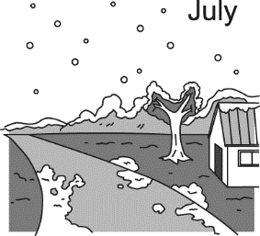 | （B）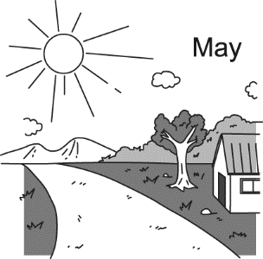 | (C) 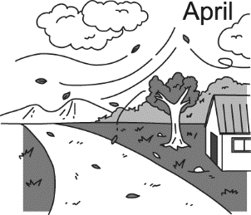

（A）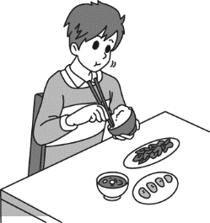 | （B） | (C) 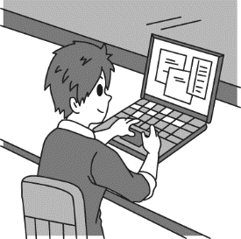
3.
（A）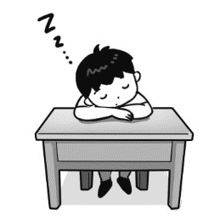 | （B）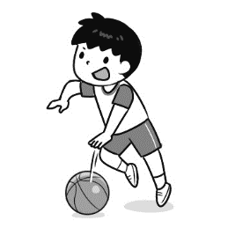 | (C)

（A）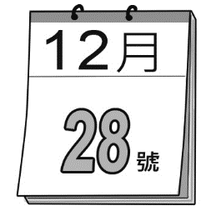 | （B）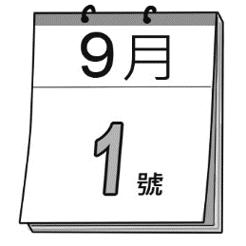 | (C) 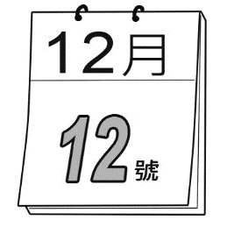

- 基本問答：根據聽到的內容，選出一個最適合的回應或最適合的問句。
- (A) It is snowy and cold.
(B) I don’t like the weather there.
(C) I want to take a trip to Toronto.
- (A) Not really. It was a good book.
(B) Yes, the book was very boring.
(C) Yes, I did. He told me he wanted to read it this weekend.
- (A) I enjoy the dinner very much.
(B) I usually take a walk with my dog.
(C) I don’t do anything before dinner.
- (A) I like to listen to music.
(B) It is a very interesting club.
(C) I learn how to play the violin.
- 言談理解：根據聽到的內容，選出一個最適合的答案。
- (A) It is cold and snowy.
(B) It is cool and rainy.
(C) It is warm and sunny.
- (A) He likes to stay at home.
(B) He likes to go swimming.
(C) He likes to have some ice cream
第二部分、閱讀理解（共60分，每題2分，請將答案畫記在答案卡上）
一、綜合選擇題（11-25）：請選出一個最適合的答案。
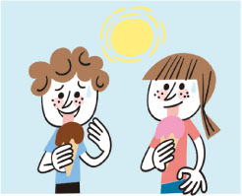
- 根據圖片，選出一個最適合的答案。
- Tim eats snacks when he watches movies.
(B) James practiced the piano after he had lunch.
(C) Before they go to bed, they always drink a glass of milk.
(D) When the weather is hot, the kids eat ice cream.
- Tina’s dad always __________ his work in the office. He never takes it home.
- orders (B) gives (C) finishes (D) learns
- A: There’s a __________ man at the door. B: Don’t open the door! Let’s get some help.
- interesting (B) poor (C) wrong (D) strange
- My uncle took a lot of pictures with his new __________ when he visited Great Wall of China.
- camera (B) engineer (C) history (D) violin
- Ms. Parker has her __________ farm. She likes to grow fruits and vegetables.
- own (B) free (C) fun (D) same
- There are four __________ in a year. Spring is my favorite.
- postcards (B) seasons (C) subjects (D) robots
- __________ lots of rain in Hokkaido last winter?
- Is there (B) Does it (C) Did they have (D) Were there
- Maggie was tired __________ she did the dishes and cleaned the house.
- but (B) until (C) although (D) after
- Halloween is coming, so my cousin, Ted, __________ a jack-o-lantern for me.
- gives (B) makes (C) shows (D) sends
- The teacher __________ the lesson with a game.
- pulled (B ) ended (C) told (D) heard
- Bella’s hands are dirty, but __________ not.
- her are (B) mine is (C) his are (D) yours is
- When I heard about the club, I thought __________ you.
- on (B) of (C) in (D) between
- A: Can I think about it and call you back? B: ____________________.
- Sure. Talk you later. (B) Really, I like computer science, too.
(C) Are you in any school club? (D) Yeah. Can I have a look.
- A: ____________________ B: It is mine.
- Did you get it? (B) Whose is it?
(C) It was a gift for my birthday. (D) How was your trip to Australia?
- A: ____________________ B: Sorry. You have the wrong number.
- You know what? (B) Are you pulling my leg?
(C) Hello, this is Mandy. May I speak to Diana? (D) Why were you in a gray jacket?

二、克漏字與閱讀測驗：請選出一個最適合的答案。
(26-30)
Now, many wild animals are disappearing from the earth. _____26_____, the number of brown bears is also decreasing. What can we do to help _____27_____ those endangered animals? Here are some good ways to help them.
- Do not buy _____28______ made from endangered animals.
- Stop catching or selling endangered animals.
- _____29_____ a tree or build a birdhouse in the back of your house.
- No polluting. Let the earth became a better and cleaner place to live.
- Learn all about endangered animals and__________30___________ with your friends. Let them know the importance of endangered animals.
disappear 消失 decrease減少 endangered瀕臨絕種的 pollute污染 importance重要

- (A) Because (B) During (C) For example (D) After that
- (A) save (B) saved (C) safe (D) saving
- (A) one thing (B) something (C) everything (D) anything
- (A) Make (B) Plant (C) Bring (D) Cut
- (A) buy the clothes made from animals (B) share your knowledge (C) play online games (D) study English after class

(31-34)
Dear Aunt, Saturday, Sep. 24th
How is everything in the USA? We’re good in Keelung. Tina and I miss you very much. We had a good time with you in Florida three years ago. You took us to Disneyland then. It was so fun.
This summer, Mom and Dad took us to Hualien Ocean Park. When we watched the dolphin show, one dolphin suddenly jumped up and kissed Tina. She was scared and cried. Ha-ha. Then, we had ice party and water fights in outdoor plaza. Some kids were fighting with water guns, and some were pouring the ice cube to each other. That was so interesting. Hope you can come to visit us someday in the future. By the way, Mom told us cousin Teddy got hurt by an accident at school. Wish him would get well soon.
Best Wishes!
Love,
Lilyanne

plaza 廣場 ice cube 冰塊 accident 意外

- What did Lilyanne mainly tell her aunt in the letter?
mainly 主要地
- Her mother got a cold and didn’t feel well.
- Her sister was sad when a dolphin kissed her.
- They went to Hualien Ocean Park this summer.
- They had fun with their parents in Florida.

- When did Lilyanne and her sister visit their aunt?
- Sep. 24th.
- Last summer.
- This summer.
- Three years ago.

- What does water fights look like?

(A)  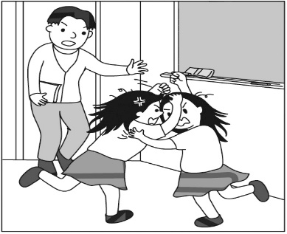 | (B) 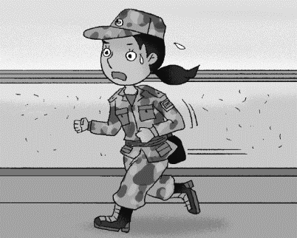 | (C)  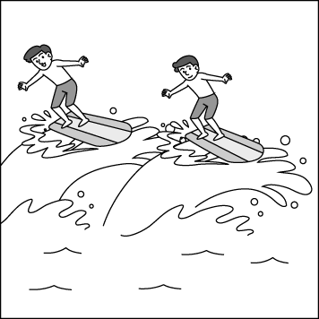 | (D)  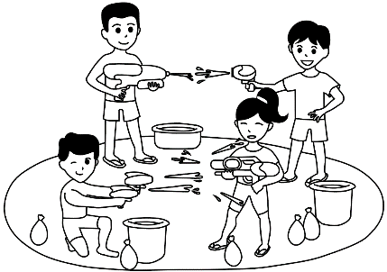

- Which is true about the letter?
- Lilyanne’s family live in the USA.
- Teddy got hurt at school.
- Tina’s parents love dolphins.
- Lilyanne’s aunt will visit her soon.

(35-36)
This chart shows the subtropical monsoon climate in Keelung City, Taiwan. Take look at its rainfall and temperature for every month, and you can know more about the climate in Keelung City.

- Every month, the temperature is above 18ﾟC.
- Every year, rainfall is above 1500mm.
- In winter, Keelung City is wet and rainy because the northeast monsoon passes through the ocean.
- In summer, it is hot because the southwest monsoon laboriously crosses the mountains to get to the city.

After 1990s, with the impact of global climate change in recent years, the rainfall in Keelung City began to decline every year, and serious drought occurred in several years.
subtropical monsoon 副熱帶季風 rainfall降雨量 temperature 溫度 climate 氣候 laboriously 費力地 decline 減少 drought乾旱companion同伴 certificate 證書

- What is the weather like in December in Keelung City?
- It’s snowy and cold. (B) It’s windy but warm. (C) It’s dry and very hot. (D) It’s rainy and wet.
- Which is true about Keelung City?
(A) The rainfall every year is below 300mm.
(B) It is wet and rainy in Keelung City in winter.
(C) It is cool in summer because the southwest monsoon easily get through the city.
(D) Because of the global climate change, there is no rain in Keelung City in summer.

(37-40)
Street Dance Club | On our Street Dance Club, you’ll learn several and different commercial styles and routines from popping and locking. Besides, you’ll learn technique moves and create your own unique dance style with freestyle sessions. Also, you will have performance training during the lessons, and you might perform on stage or have chance to attend dance contests. That will be challenging and fun, too! Don’t miss it! Come and join us.
Photography Club | Are you a fan of taking photos? Do you want to be a photographer? A big photo show is at our school Art Gallery right now. Come to visit us and get more information. In the class, some famous photographers will come to our school for teaching. At the end of the semester, beside we will show your works at school Art Gallery, we also plan to visit the International Exhibition of Photography! Join us!
Anime Club | Are you interested in Japanese culture and language? On our club, you’ll learn to speak some Japanese. You can read anime for free and discuss it as a group. The most attractive activity is to watch anime TV shows and movies. Our year-end event is to plan a club trip to an anime convention! Isn’t it great and fun? You can’t miss it!
Cooking Club | Are you a lover of food? Do you like to cook? Then, this club is for you. There are different lessons every class about different dishes. Besides, you can vote for the dishes you want to learn each semester. What’s more, we have year-end party every year. We also invite school photography club members to take pictures for our food in the party. Those pictures would be showed at school Art Gallery. That will be fun! Come and join us right now!
Foreign Film Club | Do you like to watch movies? We’ll watch a new foreign film at each meeting and discuss it. On the club, you’ll learn to host a foreign film festival and you can create your own short foreign films. The most interesting event is to plan the club summer break trip to National film festival. Don’t hesitate! Join us!
commercial 商業的 routines舞步 technique 技術 perform on stage舞台表演 anime動漫 discuss 討論 event 大事 convention大會 vote 投票 hesitate 猶豫

- Which club members would have the chance to perform on stage?
(A) Cooking Club. (B) Street Dance Club. (C) Anime Club. (D) Foreign Club.
- Kent likes movies and he is also a big fan of Japanese culture. Which club meets his need?
- Anime Club.
- Street Dance Club.
- Photography Club.
- Foreign Film Club.
- Abby is a member of the photography club, and she likes to take pictures of food. What kind of events would she visit at the end of the semester?
- The school Art Gallery exhibition and National film festival.
- A club trip to an anime convention and the year-end food party.
- The stage performance and Art Gallery exhibition.
- The year-end food party and the International Exhibition of Photography.
- Which is not true?
- A street dance club member can create his/her own unique dance.
- Members can learn to host a foreign film festival at the foreign film club.
- Some famous photographers will attend the club summer break trip.
- The anime club members can read and watch free anime.

試題結束

