111學年度第一學期 基隆市立中山高級中學
國中三年級英語科 第二次段考試題
年 班 座號： 姓名：
選擇題分數:
非選題分數:
總分:

選擇題部份: (1~49題)總共70分

- 基本問答：根據聽到的內容，選出一個最適合的回應或最適合的問句。（每題2分，共10分）
- （ ）
(Ａ) Luckily, she gave me a hand.
(Ｂ) Her hands were burned by fire.
(Ｃ) She had to hand in the report yesterday.
- （ ）
(Ａ) No, it was just an accident.
(Ｂ) Yes, he stood in the middle of the road.
(Ｃ) Yes, I am so sad to hear the bad news.
- （ ）
(Ａ) We can take care of the children at the playground.
(Ｂ) It is very far away from here.
(Ｃ) We had a good time there.
- （ ）
(Ａ) It is a book about cooking.
(Ｂ) I should read it again and again.
(Ｃ) In 2018.
- （ ）
(Ａ) Yes, I am excited to go with you guys.
(Ｂ) Yes, it was so terrible.
(Ｃ) No, I don’t have to work today.

二、言談理解：根據聽到的內容，選出一個最適合的答案。（每題3分，共9分）
- （ ）
(Ａ) The man.
(Ｂ) The man’s grandpa.
(Ｃ) The woman.
- （ ）
(Ａ) In the school.
(Ｂ) At a senior center.
(Ｃ) At the zoo.
- （ ）
(Ａ) Chinese class.
(Ｂ) Computer class.
(Ｃ) Math class.

- 字彙選擇：（每題1分，共10分）
- ( ) My brother now is in the 9th , and he is going to a senior
high school this September.
(Ａ) grade (Ｂ) class (Ｃ) subject (Ｄ) book
- ( )My wife asked me to buy a eggs on my way home after
work. She needs twelve eggs to make a birthday cake for our only
son.
(Ａ) wallet (Ｂ) piece (Ｃ) dozen (Ｄ) bottle
- ( ) Dear, thank you for the cake like a heart. I pray our love
for each other will last forever.
(Ａ) saving (Ｂ) shaping (Ｃ) typing (Ｄ) boiling
- ( ) The TV is so funny that I can’t stop laughing when
watching it.
(Ａ) tool (Ｂ) screen (Ｃ) nail (Ｄ) program
- ( ) The soldier’s legs are in the war. He can’t walk with his
feet anymore.
(Ａ) changed (Ｂ) createded (Ｃ) barked (Ｄ) injured
- ( ) Lemon is in Vitamin C（維他命 C）. It’s good for our
health.
(Ａ) rich (Ｂ) big (Ｃ) poor (Ｄ) strong
- ( ) Jack often in the library to help check out books.
(Ａ) volunteers (Ｂ) prepares (Ｃ) studies (Ｄ) prays
- ( ) James has green fingers, so he likes to do in his free time.
(Ａ) painting (Ｂ) studying (Ｃ) gardening (Ｄ) exercising
- ( ) Jenny is getting slimmer and slimmer exercising and
being on a diet.
(Ａ) behind (Ｂ) through (Ｃ) without (Ｄ) from
- ( ) They down all the old houses in this area because they’re
going to build a new department store here.
(Ａ) knocked (Ｂ) fell (Ｃ) broke (Ｄ) kicked

四、文法選擇：（每題1分，共21分）
19. ( ) The cake in a short time because of the good taste.
(Ａ) was eaten up (Ｂ) is eating up
(Ｃ) ate up (Ｄ) eats up
20. ( ) Cindy: Why isn’t the dress going to by Kelly?
Sam: Because it in Taiwan.
(Ａ) buy; will make (Ｂ) buy; isn’t making
(Ｃ) be bought; won’t make (Ｄ) be bought; isn’t made
21. ( ) Harry Potter J. K. Rowling.
(Ａ) wrote; about (Ｂ) is written; with
(Ｃ) writes; of (Ｄ) was written; by
22. ( ) The happiness（幸福）comes from people need.
(Ａ) help; by (Ｂ) helping; in
(Ｃ) to help; of (Ｄ) helped; on
23. ( ) ROC the Republic of China.
(Ａ) stands for (Ｂ) gives up
(Ｃ) blows up (Ｄ) knocks on
24. ( ) Lisa asked her mom she remembered the wake word
or not.
(Ａ) that (Ｂ) why (Ｃ) how (Ｄ) if
- ( ) I need a computer and a smartphone, but I can’t decide .
I don’t have enough money for both.
(Ａ) which to buy first (Ｂ) how to buy them
(Ｃ) when to buy them (Ｄ) where to buy them
26. ( ) The man badly. He should to the hospital right
away.
(Ａ) hurts; send (Ｂ) hurts; have sent
(Ｃ) is hurt; be sending (Ｄ) is hurt; be sent
- ( ) The treehouse by Dad, so he can’t help me with the math
problem now.
(Ａ) has been built (Ｂ) is being built
(Ｃ) builds (Ｄ) is building
- ( ) Something to help poor students.
(Ａ) have to do (Ｂ) need doing
(Ｃ) should be done (Ｄ) must do
- ( ) We’re not sure they have seen the latest Korean movie.
(Ａ) when (Ｂ) that (Ｃ) how (Ｄ) whether
- ( ) Joseph: I’m so hungry. I’d like to know we can enjoy a
good meal.
Brian: How about right now? I’m as hungry as a bear, too.
(Ａ) where (Ｂ) if (Ｃ) that (Ｄ) when
- ( ) Do you really want your parents understand you feel
and you think?
(Ａ) how; what (Ｂ) how; how
(Ｃ) what; how (Ｄ) what; what
- ( ) Can you tell me ?
(Ａ) where should I save the file
(Ｂ) how to save the file
(Ｃ) how have you haved the file
(Ｄ) how long does it take to save the file
- ( ) Sorry, sir. You to take photos in the museum.
(Ａ) don’t allow (Ｂ) didn’t allow
(Ｃ) aren’t allowed (Ｄ) haven’t allowed
- ( ) Wendy has no idea who for help when she is in trouble.
(Ａ) to ask (Ｂ) is asking (Ｃ) be asked (Ｄ) can she ask
- ( ) Everyone in the class takes turns the blackboard（黑板）
between classes.
(Ａ) clean (Ｂ) to clean (Ｃ) being cleaned (Ｄ) cleaning
- ( ) After the doctor, Daniel to take the medicine
three times a day.
(Ａ) being seen; was asked (Ｂ) seeing; was asked
(Ｃ) he sees; will ask (Ｄ) to see; will be asked
- ( ) In 2011, many people during the tsunami（海嘯）in
Japan.
(Ａ) lose their lives (Ｂ) killed (Ｃ) are killed (Ｄ) died
- ( ) Many things happened since we left Taiwan.
(Ａ) have been (Ｂ) have (Ｃ) were (Ｄ) ×
- ( ) Jim: Do you know ? Sara: Sorry, I have no idea.
(Ａ) whose jacket is it (Ｂ) where can I buy nails
(Ｃ) which tool should I use (Ｄ) if I typed the word right

- 閱讀測驗：（每題2分，共20分）

(1)
A Good Stay makes you fresh every day.



A stay to a smart house / Two days
Keelung, Taiwan
NT$2,000~3,500 / person

Stay in the smart house for two days, and you’ll get interesting and surprising experiences.
＊During the day time, you may have a road trip with our Goody self-driving car.
＊Make a call and you can sit at the table and watch Chef Yummy, the robot, cook for you.
＊At night, clap your hands to see through the windows and enjoy the moonlight bright.
＊Need some exercise? Exercise anytime in your bedroom. Say “Hi, Ms. Healthy!” You’ll see Ms. Healthy, your trainer, at the bedroom door.
＊Push the buttons in the house, and there are more for you to find out.
＊10% off for early birds (1 month before your stay).
＊Change your mind after you book your stay? No worries. You can get all your money back a week before your stay.
[P.S. You’ll get an e-ticket only.]

Check in: 3 p.m.
Check out: 12 p.m.

Choose a date.
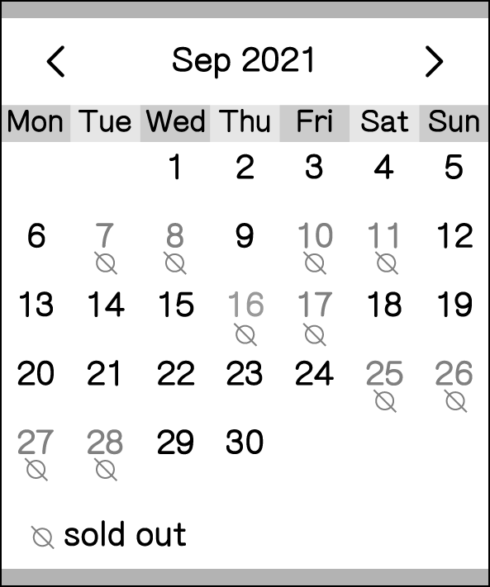
Number of people:
Adult (over 12 years old) NT$3,500 -0+
Children (3~12 years old) NT$2,000 -0+
Baby (0~3 years old) NT$0 -0+
Pay now

Are there any special needs?
Eg: 1 baby chair in the dining room.
- ( ) What CAN’T people do at this page?
(Ａ) Buy birds there.
(Ｂ) Know more about the smart house.
(Ｃ) Write about their special needs.
(Ｄ) Book their stay at the smart house.
- ( ) It’s September 8. Mr. and Mrs. Chen would like to visit the smart
house with their six-year-old child next week. They will stay there
for two days and one night. How much do they have to pay?
(Ａ) NT$6,300. (Ｂ) NT$7,000.
(Ｃ) NT$8,100. (Ｄ) NT$9,000.
- ( ) Look at the picture. What did the man do in picture three?
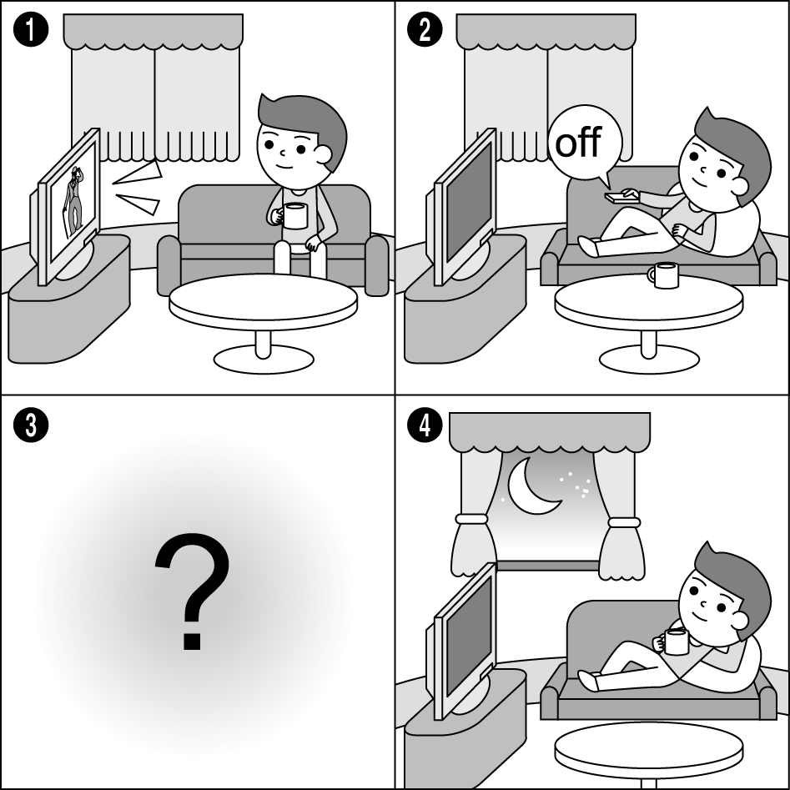
(Ａ) 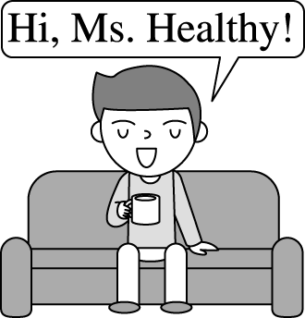 (Ｂ) 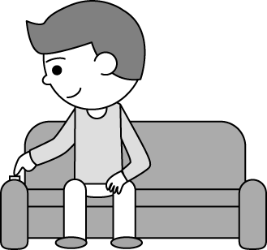
(Ｃ) 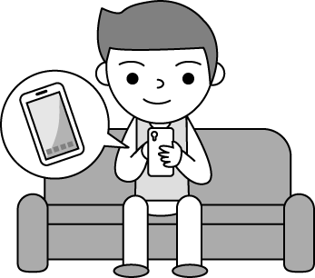 (Ｄ) 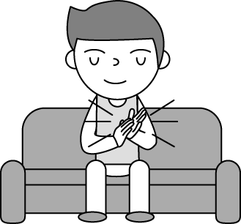
(2)
Victor was a soldier when he was young. In 1975, his city was attacked by bombs, and his family and friends were all killed, so he was the only survivor. Since then, he has had PTSD. Sometimes he can’t fall asleep, and sometimes he dreams of bomb attacks.
PTSD is a mental disorder, and people may have it after experiencing frightening events. Such as a serious car/train/plane accident, fighting in a war, or being abused may all cause PTSD.
When people have PTSD, they may have sleeping problems. They may also avoid being around people or doing some things because they don’t want the terrible events to come back to their mind.
Luckily, PTSD can be treated in some ways. If you think you have PTSD, go to the doctor as soon as possible and don’t be afraid to talk about your problems. You will feel better sooner if you get treated earlier.
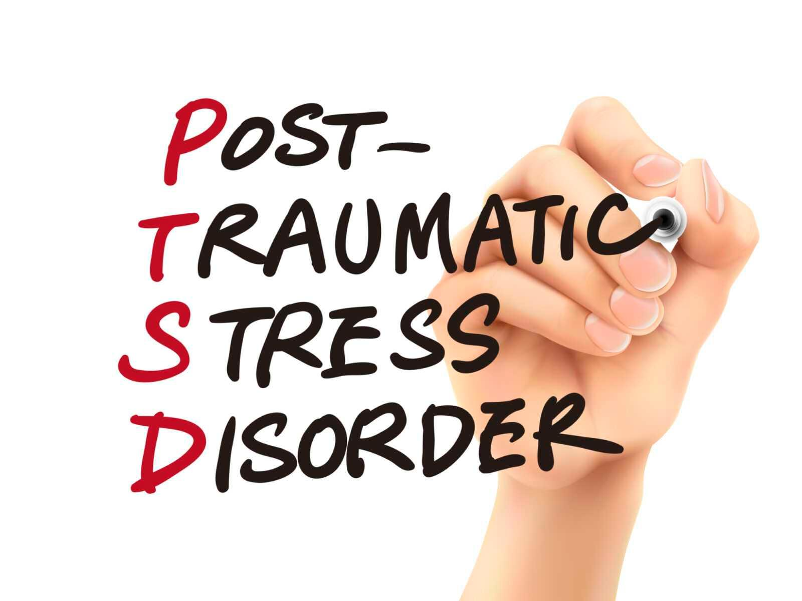

- ( ) What does frightening mean?
(Ａ) Scary. (Ｂ) Missing.
(Ｃ) Interesting. (Ｄ) Surprising.
- ( ) Which person might have PTSD?
(Ａ) Charles. He often has sweet dreams at night.
(Ｂ) Kate. She enjoys watching movies about wars.
(Ｃ) Ruby. She is afraid to drive because of a serious car accident
two years ago.
(Ｄ) Ed. He enjoys his job as a doctor although sometimes he is
not able to save lives.
(3)
Do you believe that breaking a mirror will bring seven years of bad luck? Lots of Americans do. They also believe that if someone sings before 7:00 a.m., he or she will cry at eleven, which means the morning is too early to be happy. Everyone wants to try hard every day to be lucky. What’s more, there’s a taboo about shoes. That is to say, don’t put shoes on the table, or it would bring very bad luck to the family.
About sending gifts, in America, if someone gives you a knife as a gift, you have to pay one dollar for it, or the gift will bring you bad luck. And if someone gives you a beautiful box of hand-made cookies, don’t give the box back with nothing inside. That is also believed to be unlucky and will bring hunger to the family.
One more funny thing is that Americans will say “break a leg” to wish someone good luck if he or she is going to perform in public. It is interesting, isn’t it?

- ( ) What is the reading about?
(Ａ) Knives and shoes in America.
(Ｂ) American superstitions（迷信）.
(Ｃ) Sending gifts in America.
(Ｄ) American popular gifts.
46. ( ) What does taboo mean in the reading?
(Ａ) Something that will bring good luck.
(Ｂ) Something that is interesting to do.
(Ｃ) Something people should not do.
(Ｄ) Something people are happy to do.
47. ( ) Which is true about the reading?
(Ａ) Americans think putting shoes on the table will bring bad luck
to the family.
(Ｂ) A knife is the best gift for Americans.
(Ｃ) Americans think saying “break a leg” will not bring people
good luck.
(Ｄ) Americans always sing before 7:00 a.m. to bring good luck.
(4)
Making menus is not just putting words and pictures together. You have to know some psychological tricks to make great ones. You can often find these tricks on restaurant menus. Here are some examples. First, restaurants use colors to give you different feelings. For example, green implies the food is fresh, yellow catches your eye, and orange makes you feel hungry. Besides, restaurants often put decoys on their menus to make other dishes look better. For example, a NT$600 steak may be expensive to you. However, when the restaurant uses a NT$550 meat pie as a decoy, it makes the steak look like a better buy, and you will be more willing to order the steak than the meat pie.
Here’s another trick. Many restaurants use the number 9 more often than zero on their menus. There is only a price difference of one dollar, but people feel NT$99 is a lot cheaper than NT$100. Also, some restaurants take away the dollar sign($) on their menus because
“ 150 ” looks more friendly than “$150.”
The psychological tricks behind menus may be interesting, but they might make you spend more money than you want to. Next time when you eat at a restaurant, take a good look at their menu before ordering food.

48. ( ) According to（根據）the reading, which one is a decoy to trick
people?
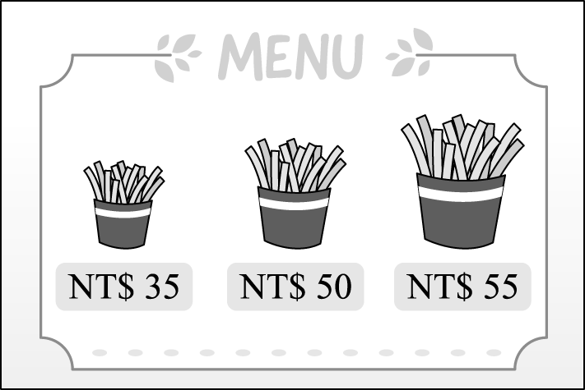
(Ａ) The large one. (Ｂ) The medium one.
(Ｃ) The small one. (Ｄ) The small one and the large one.
49. ( ) What is the purpose of the reading?
(Ａ) To teach readers how to order cheap and delicious food at
restaurants.
(Ｂ) To teach readers how to use the psychological tricks to make
great menus.
(Ｃ) To tell readers to choose honest restaurants when they want
to eat out.
(Ｄ) To tell readers not to spend more money because of the
psychological tricks behind menus.

非選題部份: (50~77題) 請將答案填寫在非選題作答卷中

六、課文佳句配合題：（每題2分，共10分）
將以下方格中的字彙組別代碼配對到適當的句子當中。
代碼 | A | B | C | D | E
 | but | what | sure | for | shape
代碼 | F | G | H | I | J
 | way | invite | nothing | come | in
50. That way, people can help him find his __________ home.
這樣一來，人們就可以幫他找到回家的路。
51. I know __________to do next. 我知道接下來該怎麼做。
52. He had __________ in his pocket __________ a nail.
他口袋裡除了一根釘子，什麼都沒有。
53. The taste came from helping people __________ need.
這滋味是來自於幫助有需要的人。
54. IoT stands __________ Internet of things.
物聯網代表「物與物相連的網路」。
55. We will have to cross that bridge when we __________ to it.
我們不必憂慮，到時候就順其自然吧。
56. No one can know for __________ how IoT will __________ our lives. 沒有人能肯定物聯網會如何影響我們的生活。
57. A: Did you __________ Jean? A: 你有邀請珍嗎？
B: Yes I did./ No, I did not/ didn’t. (But I invited Mary.)
B: 是的，我有/不，我沒有。(但我有邀請瑪麗。)

七、請填入課本單字或片語：（每題1分，共10分）
58. 小考 | 59. 紙條 | 60. 口袋 | 61. 水管 | 62. 種子
63. 爆炸 | 64. 現代的 | 65. 上傳 | 66. 按鈕 | 67. 及時

八、請填入佳句卷的單字：（每題1分，共10分）
68. 樂趣 | 69. 圖書館 | 70. 錢 | 71. 麵條 | 72. 幫助
73. 禮物 | 74. 醫院 | 75. 晚的 | 76. 飢餓的 | 77. 飛機

【測驗結束】
請記得仔細檢查，避免粗心錯誤!

