基隆市立中山高中國中部八年級 英語科 第三次段考試卷
年 班 座號： 姓名： (題目共四頁)
1-5 CCCBB 21-25 ABDCB 41-45 DBCDC 55. AB 58. BD
6-10 BBABA 26-30 DDBBD 46-50 DCABD 56. CD 59. BC
11-15 CDCBB 31-35 ACBDD 51-54 BACD 57. AC 60. AD
16-20 DBCDD 36-40 CBABD

口試10% | 選擇90% | 總分

一、辨識句意：根據聽到的內容，選出符合描述的圖片或符合圖片的描述。3%
1. ( ) (A) 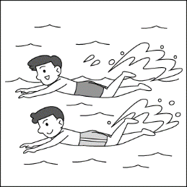 (B) 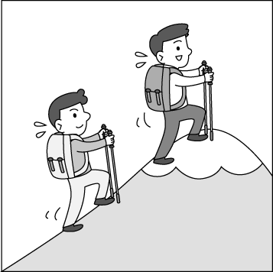 (C) 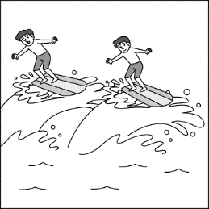
2.( ) (A) 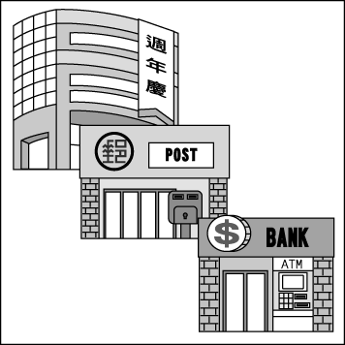 (B) 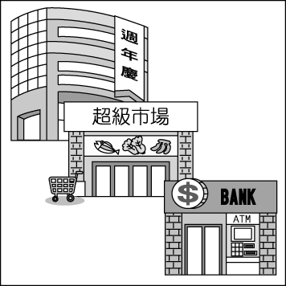 (C) 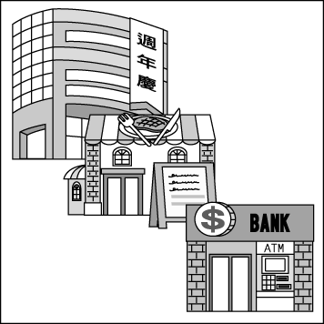
3.( ) (A) 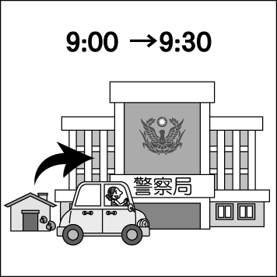 (B) 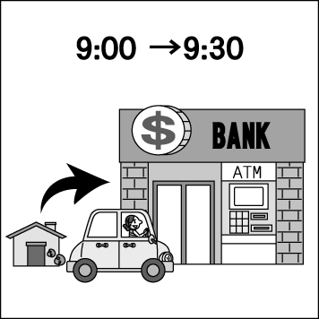 (C) 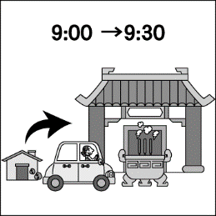

二、基本問答：根據聽到的內容，選出一個最適合的回應或最適合的問句。4%
4. ( ) (A) I am going to Tokyo. (B) In two days. (C) I was in Japan last week, too.
5. ( ) (A) She is reading a novel now. (B) She is going to buy some gifts for her mom.
(C) She is very busy this afternoon.
6. ( ) (A) Come to my office at 1 p.m. (B) I always ride my scooter there.
(C) There are so many people in my office.
7. ( ) (A) I am sorry. I am lost. (B) Do you see the fire station? The school is on the left.
(C) It is not very far from here.

三、言談理解：根據聽到的內容，選出一個最適合的答案。3%
8. ( ) (A) Go shopping. (B) Wash the clothes. (C) Go biking at the park.
9. ( ) (A) The bus stop. (B) The police station. (C) The train station.
10. ( ) (A) NT 410. (B) NT 590. (C) NT 1,000.

四、單選題 50%
11. There’s a supermarket on the corner, and the hotel is ____ it.
(A) between (B) next (C) across from (D) straight to
- The girl ___ a bike to the park.
- ride (B) riding (C) to ride (D) rode
- A : ____ did they go to the museum this morning ? B : They went to the museum ___.
- Where, on taxi (B) What, by a taxi (C) How, by taxi (D) When, in taxi
- I was busy ___ pictures when the clock ___ twelve.
(A) to take, was (B) taking, hit (C) taken, cost (D) take, by
- ___ nice ___ you !
(A) What, for (B) How, of (C) And, to (D) It’s , and
- There will ___an ugly Christmas sweater party tomorrow.
(A) have (B) has (C) is (D) be

- ___ does it take ? It takes about two hours.
(A) How much (B) How long (C) How many (D) How about
- ___ does it cost ? It costs five hundred NT dollars.
(A) How many (B) How long (C) How much (D) How about
- They ___ three hours ___ to the park.
(A) took, drive (B) cost, to drive (C) paid, driving (D) spent, driving
- What is Pam going to do next Tuesday ? She ___ visit the science museum.
(A) will be (B) is going (C) going to (D) is going to
- A : ___ you have a pink skirt ? B : Yes, I do.
(A) Do (B) Does (C) Did (D) Are
- A : Does the girl study English every day ? B : No, she ___.
(A) does (B) doesn’t (C) is (D) do
- I ___ to music on Friday evening. She ___ to music on weekends.
(A) listens, listen (B) listens, listens (C) listen, listen (D) listen, listens
- Jack : There is going to ___ a dance show on Saturday. Would you like to go with me?
Nina : Sure, I can’t wait for it.
(A) get (B) do (C) be (D) have
- Although it cost me NT$50,000 ＿＿＿ a trip to Japan, I still want to go there again.
(A) taking (B) to take (C) took (D) take
- A：Is Mark’s Toy Factory ______ a park and a museum?
B：Yes, just walk down the street for three blocks, and you can see it ______ the right after you go past the museum.
(A) on the corner of; next to (B) across; on (C) in the back of; by (D) between; on
- It usually ___ Joyce 40 minutes ___ to school.
- spends, on foot (B) takes, walking (C) spends, walking (D) takes, to walk
- Please tell us about your ____ in Africa.
- expensive (B) experience (C) wonderful (D) bank
- What ___day !
(A) wonderful (B) a wonderful (C) wonderful a (D) this wonderful
- His sick father is in the ___.
- motorcycle (B) thousand (C) change (D) hospital
- My watch is three minutes ___.
- fast (B) most (C) pool (D) ship
- The ___ number of the students is 500.
- save (B) price (C) total (D) play
- Go ___ the street for two ___. And turn left on the Berkeley Street.
- down, supermarkets (B) along, trains (C) along, blocks (D) down, cities
- He took the ___ child to the police station.
- left (B) around (C) pair (D) lost
- The ___ of the bells was beautiful, and many people stopped to listen.
(A) ground (B) map (C) second (D) sound

五、題組 (36-40題一題2分, 41-50一題1分)20%

(Mike is in a bookstore, and he is talking to Ted.)
Mike：__36.__ Is that a book about Marble Canyon（大峽谷）?
Ted：Yes, it is. Why do you ask?
Mike：I don’t know much about it. Is it a good place to visit?
Ted：Of course. __37.__, and there are many other fun activities in the area. You can go camping, river tracing, and swimming in the lake.
Mike：Wow, that’s cool! Are there any interesting places to visit?
Ted：There are tons, like the Marble Canyon Museum. When you go, __38.__. Everything about the area and its history is in there.
Mike：Thanks, that’s good to know. And how can I go to Marble Canyon?
Ted：I suggest you go there __39.__ train. It won’t take long.
Mike：I see. Is getting a train ticket down there a nightmare?
Ted：__40.__, but I never had any problems getting one on the Internet.
Mike：OK. Thanks a lot.
area 地區 river tracing 溯溪 tons 許多 suggest 建議 nightmare 夢魘
- (A) I’m so sorry. (B) Just forget it. (C) Excuse me. (D) I see. Thanks.
- (A) It has great video games (B) Hiking there is a big thing (C) The stores are old (D) I won’t visit there
- (A) you won’t want to miss that (B) please don’t cross the line (C) stay away from that place(D) don’t make any mistakes
- (A) on (B) by (C) with (D) for
- (A) I don’t have one (B) Everything will be all right (C) It is really cheap (D) It can be a little difficult

Tell me when we get there
“Is this stop Bloomington ? “ and old lady asked the bus driver.
“No, ma’am.” the driver said.
“Well, please tell me when we get there.” She said.
“I’ll do that.” said the driver.
Later, the driver got careless and passed through Bloomington before he knew it. He apologized to the other passengers, turned around, and drove back. The he said to the old lady : “This is the town where you wanted to get out.”
“Who wanted to get out ? “ she asked.
The driver said, “ You did.”
“No,” she said, “my daughter told me that when I pass through this town, I should take my medicine.”

- Who wanted to get out at Bloomington ?
- The bus driver. (B) The old lady. (C) The old lady’s daughter. (D) No one.
- The driver didn’t stop at Bloomington the first time because ___.
- The old lady forgot to tell him. (B) He got careless and forgot. (C) It wasn’t on his road. (D) He had engine problems.
- The driver apologized to ___.
- the old lady. (B) the old lady’s daughter. (C) the other passengers. (D) no one.
- The old lady wished to be reminded when the bus passed Bloomington because ___.
- she wanted to get out. (B) she wanted to get on.
(C) she wanted to eat lunch. (D) she wanted to take some medicine.
- “Apologize” means ___.
- go biking (B) be on sale (C) say sorry (D) take off

Welcome to Dream Plan! If you are visiting here, that means you are planning for your wedding! Did you think about your dream wedding? With our wedding package, you get everything you need, from wedding dresses to cakes and flowers.
As for wedding venues, hotels are a popular wedding choice. 70% of our customers held their weddings at hotels, 23% of them held theirs at restaurants or coffee shops, and still others preferred outdoor weddings, like being at a beach or a place with a beautiful view.
Before we start, here are some questions. What kind of wedding would you like? How much do you want to spend on your wedding? How many people will you invite? This might look like a lot of work, but don’t worry. We are here to help you plan your dream wedding.
package 套裝規劃 choice 選項 customer 顧客 prefer 更喜歡 outdoor 戶外的 service 服務

- Many people called Rita after they saw the ad. Which is most likely true? likely 可能
(A) “I’m Jason. I need some great ideas for my family vacation.”
(B) “This is Helen calling. My husband spends too much time on his phone…”
(C) “I’m Peter. I want to start my own wedding planning business…”
(D) “I’m Betty. I want to have a wonderful wedding day.”

- What does “venue” mean?
(A) 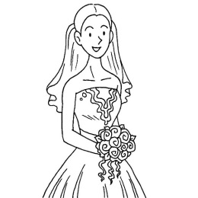 (B) 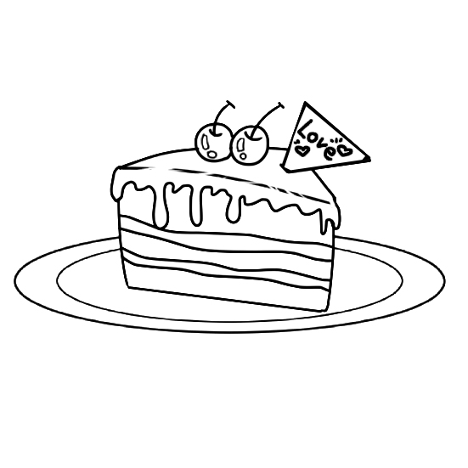 (C) 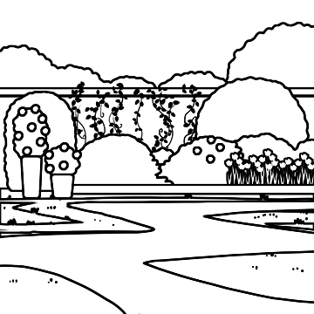 (D) 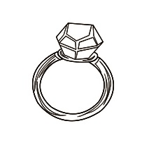
- Where can you see this ?
- On the Internet. (B) In a PE class. (C) At a train station. (D) At a fire station.
- After the wedding, the man and the woman will be ___.
- Brother and sister. (B) Husband and wife. (C) Doctor and nurse. (D) Reporter and secretary.
- According to the ad, which of the following is not a nice place for a wedding ?
(A)A beach. (B) A hotel. (C) A coffee shop. (D) A supermarket.

according to 根據 ad 廣告

六、單字配合題(51-60題請選右方代號, 答案若為兩個字母, 例如 : AB, 則畫 )10%
51. ( ) 在…之後 A. Tuesday
- ( ) 星期二 B. after
- ( ) 腳 C. feet
- ( ) 星期四 D. Thursday
- ( ) 腿 AB. leg
- ( ) 分數、重點、指向 AC. spell
- ( ) 拼字 AD. fail
- ( ) 例子 BC. repeat
- ( ) 重複 BD. example
- ( ) 失敗 CD. point

