第一部分 聽力測驗（共20分，每題2分，請將答案畫記在答案卡上）
- 辨識句意：根據聽到的內容，選出符合描述的圖片或符合圖片的描述。

（A）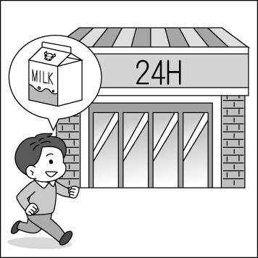 | （B）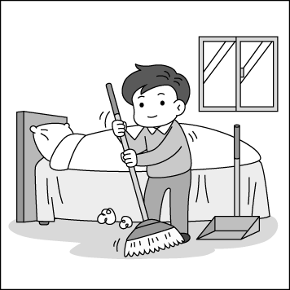 | (C) 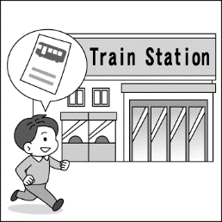

（A）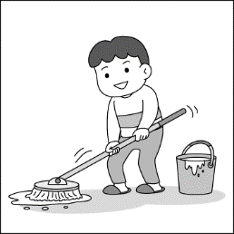 | （B）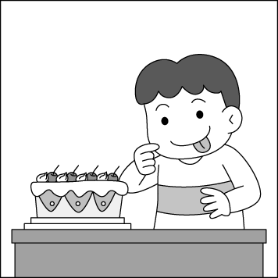 | (C)
3.
（A）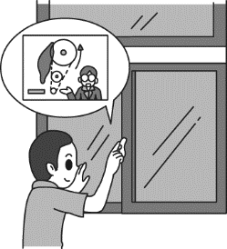 | （B）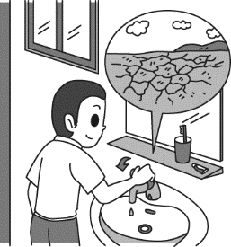 | (C) 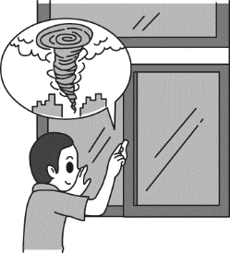

（A） | （B） | (C)

- 基本問答：根據聽到的內容，選出一個最適合的回應或最適合的問句。
- (A) Yes, she sings better than Tina.
(B) Yes, she hurt her knee badly.
(C) Yes, she dances so beautifully.
- (A) No, I played computer games at home.
(B) Yes, but only half an hour.
(C) Yes, he let me go with Mary.
- (A) I didn’t hear your voice.
(B) I need to park the car first.
(C) I saw some old men jogging.
- (A) No, I won’t. It is too dangerous.
(B) Yes, it is in the forest.
(C) No, let’s meet at three in front of my house.

- 言談理解：根據聽到的內容，選出一個最適合的答案。
- (A) He didn’t have enough sleep last night.
(B) He forgot to bring his English homework to school.
(C) He didn’t do well on the English test.
- (A) Find some food in the mountains.
(B) Take some pictures.
(C) Feed the monkeys.
第二部分、閱讀理解（共58分，每題2分，請將答案畫記在答案卡上）
一、綜合選擇題（11-25）：請選出一個最適合的答案。
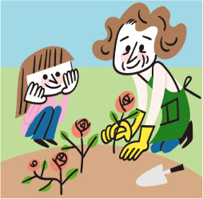
- 根據圖片，選出一個最適合的答案。
- The boy just heard someone close the door.
(B) People can feel the plane shaking badly now.
(C) The man is watching the dogs running after the butterflies.
(D) The little girl watched her grandma plant roses in the garden yesterday.
- The heaviest watermelon here is about four __________.
- pages (B) pounds (C) stars (D) million
- Sabrina is __________. She can’t stand up without help.
- giant (B) sharp (C) weak (D) latest
- After the rain, we saw a beautiful __________ in the sky.
- radio (B) candle (C) rainbow (D) balcony
- When we climbed up the mountain, we__________ some flowers along the way.
- shone (B) picked (C) reached (D) prepared
- The movie was sad, and it made everyone __________.
- cry (B) blow (C) laughing (D) to shout
- Anne studied __________ yesterday, and stayed up late for the big tests.
- hard (B) better (C) early (D) hardly
- My dog got excited when it saw the girls __________ the butterflies.
- catching (B) to catch (C) caught (D) catches
- Cocoa child workers work long hours but make very little money.
We can stop __________ chocolate from these companies for help.
- bought (B) buying (C) to buy (D) and buy
- People __________ eat and drink in the museum.
- mustn’t (B) don’t need (C) shouldn’t be (D) doesn’t have to
- Tina and I won’t see a movie if it __________ tonight.
- will rain (B) is raining (C) will be rainy (D) keeps raining
- Jeremy looked at the cake __________. He didn’t eat anything for a whole day.
- hungry (B) early (C) hungrily (D) noisy
- A: Could you help me check out this information? B: ____________________.
- Well, we live a hard life. (B) No problem. The information is true.
(C) That’s a wise thing to do. (D) Yes, my poor friends. Mr. Jones treats us badly.
- A: What size dress does Eva wear? B:____________________
- The pink one, thanks. (B) She doesn’t wear pants.
(C) Large, I think. (D) She studies the hardest of all.
- A: Even if they are poor, ____________________.
- they don’t have chance to go to school (B) they make those kids work day and night
(C) they make rescue work go faster (D) living safely and healthily by themselves is the most important thing for them.

二、克漏字與閱讀測驗：請選出一個最適合的答案。
(26-30)
People around the world have different ways to show their respect for their dead family members.
In Mexico, people celebrate the Day of the Dead from October 31 to November 2. ____26______this time, families clean the graves and put candles, flowers, drinks, and food on the graves. Then they remember _____27_____ by sharing stories of their lives. For the children in Mexico, the Day of the Dead is a happy holiday. They celebrate it by dancing and eating candy in the shape of a skull. It is a way for children to learn the circle of______28____ and not to be scared of death.
In Indonesia, the Torajan people bring the dead back home every one to three years. Families get together to clean the body, brush the hair, and put fresh clothes on the body. After that, they _____29_____ the dead for a “walk.” To the Torajan people, death is not an end. They continue to take care of their loved ones for many years even after they die.
People around the world ______30______ different celebrations for the dead. They all try to do the same thing: To remember the dead and show their love to the loved ones.
Mexico墨西哥 grave 墳墓 skull頭骨 Torajan 托拉查人

- (A) But (B) Luckily (C) During (D) Sometimes
- (A) the food (B) the fresh clothes
(C) the shape of a skull (D) the dead
- (A) life (B) world (C) times (D) garden
- (A) put on (B) turn off (C) check out (D) take out
- (A) fail (B) hold (C) lead (D) wave

(31-33)
opinion意見 bully霸凌者 dedicate 致力於 value重視 project計劃 tireless campaigning 孜孜不倦的活動參與 confidence自信
We are all different and have different thoughts and opinions. It is your right to say what you think and feel. Also, it is important to respect the opinions of others—even if you do not like them! It can be difficult to enjoy your right to tell others about yourself if you are being bullied, as Emily-Anne Rigal found out.
Emily-Anne was very unhappy at her elementary school. The other children made fun of her because of the way she looked and the clothes she wore. Nobody wanted to be her friend. Emily-Anne did not want to change her look, but the bullying made her so unhappy that she finally left the school.
At her new school, the children greeted Emily-Anne warmly, and she soon had lots of friends. Those friends liked just the way she was. As Emily-Anne grew happier she noticed that other children were being bullied—often by young people who felt bad about themselves. So Emily-Anne started the YouTube channel WeStopHate, dedicated to ending bullying by encouraging young people to value themselves. By the time she was sixteen, Emily-Anne’s WeStopHate project was reaching young people all over the world. Through posts on YouTube and other social media she gave both bullies and the bullied a space to share their experiences, discuss their fears and start to feel better about themselves, while encouraging kindness towards others. By bravely telling her own story and through her tireless campaigning, public appearances and writing, Emily-Anne has helped hundreds of young people get the confidence to enjoy their right to show themselves.

- What is the reading about?
express 表達
- How to be a Youtuber.
- Emily-Anne Regal’s life in childhood.
- Emily-Anne Regal’s efforts to change the bullying culture.
- A channel for young people to express who they truly are.

- What do we know from the reading?
- WeStopeHate is a project by Emily-Anne for adults.
- Encouraging young people to value themselves can have a chance to end bullying.
- Emily Anne’s classmates liked the way she looked and the clothes she wore.
- Hundreds of young people get confidence by helping Emily-Anne.

- Which is true from the reading?
- Emily Anne was happy with her elementary school life.
- Young people often feel terrible about themselves.
- People cannot express themselves because it is difficult to tell others about their opinions.
- When Emily was sixteen, her project, WeStopHate, was reaching to young people all over the world.

(34-36)
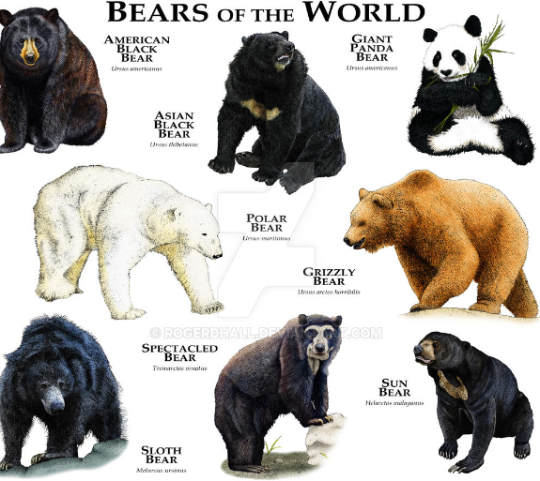 | Eight species of bears still exist today, and people think they are the largest carnivorous land animals. people can find those bears all over the world such as on the continents of North America, South America, Europe, and Asia.  We can see the map of the bears in the world below.  Bears are mammals, and come in many colors, like black, brown, and white. Polar bears are carnivorous, giant pandas are herbivores, and the other six types are omnivores, eating berries, fish, and even nuts. Bears are mostly active during the day. However, when they are worried, they sometimes stay up all night. They have a great sense of smell and are very good swimmers, runners, and climbers.
Map of the bears of the world
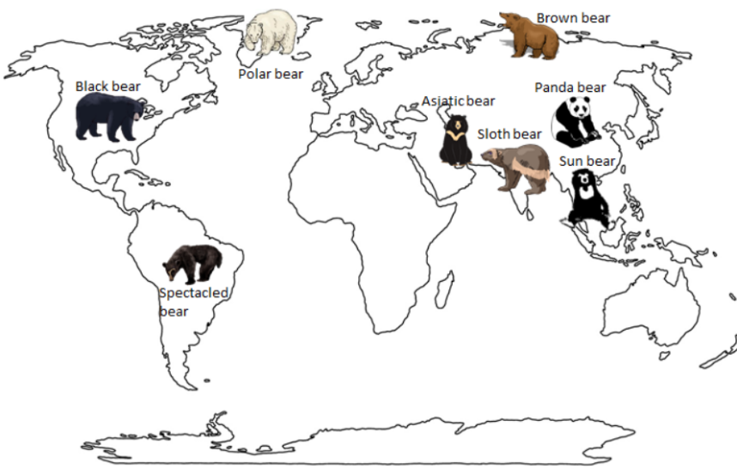
exist 生存 carnivorous肉食性的 continents 洲 herbivores 食草動物 omnivores 雜食 active活躍的
- Which continent can we find Spectacled Bears?
- Asia (B) Europe. (C) North America. (D) South America.
- Which is true about bears according to the reading?
(A) Bears has many colors like black, yellow, and white.
(B) They are good swimmers, runners, and climbers.
Antarctica 南極洲
(C) People can find them on the land of Africa and Antarctica.
(D) All of the bears are omnivores.
- It has large round ears, black fur, and V-shaped with color white on the chest. It also has a nickname-- the Moon. Which picture is a best match to the description?
chest 胸前
description 描述

(A) | 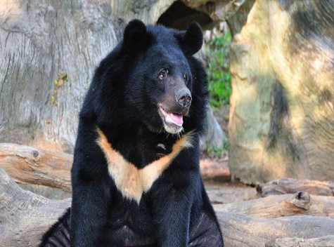  (B) | (C)  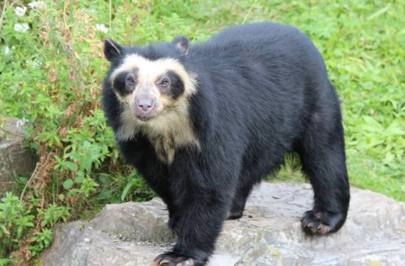 | (D)  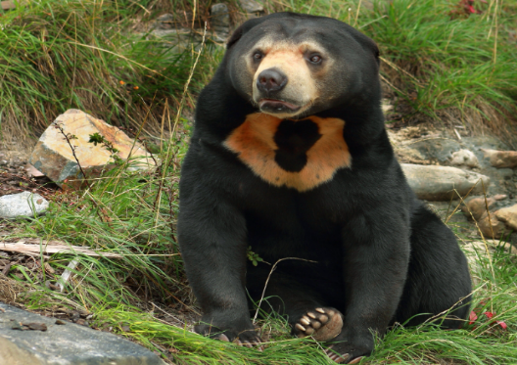

(37-39)
We can easily find plastic in our lives; from the food packaging we buy to the smartphones we use and the cars we drive. Plastic is widely used in our everyday life, However, most of the plastic we use is used only once and thrown away. Much of the plastic goes into the ocean. A study says that by 2050 there will be more plastic than fish in the world’s oceans. Sadly, plastic is killing the oceans. What can we do about it? Here are some ways that can help reduce the use of plastic:

1. Bring your own chopsticks and spoons when you eat out.
We should bring our own chopsticks and spoons with us. By doing so, we can help keep the earth from plastic pollution.
2. Stop using plastic straws.
A study says that five hundred million straws are used every day. And that is just in America. To make a change, it is as simple as asking not to get a straw with your drink when you order one.
3. Buy food at local markets.
By doing so, you can buy fresher food and save money. Most importantly, you can cut down on the use of packaging. It is healthier and better for our planet.
All the above may not be convenient. However, you do not want to live on a planet of garbage, right?
widely 廣泛地
From now on, let’s eliminate plastic from our lives!

- What does “eliminate” mean?
(A) Take away. (B) Go out. (C) Take down. (D) Look into.

- After Dennis read the poster, he wants to make some changes. What will he do?
- He doesn’t want to live on a planet of garbage.
- He will bring his own chopsticks and spoons when he eats out.
- He will use the package for saving money when he shops food at local markets.
- He will study on the straws because he likes to use different colors of the straws.

- Which is NOT true?
- By 2050, there will be more plastic than fish in the world’s oceans.
- We can help keep the earth from plastic pollution by buying food at local markets.
- People need to live on a planet of garbage because reducing plastic is convenient.
- In America, almost five hundred million straws are used every day.

試題結束

